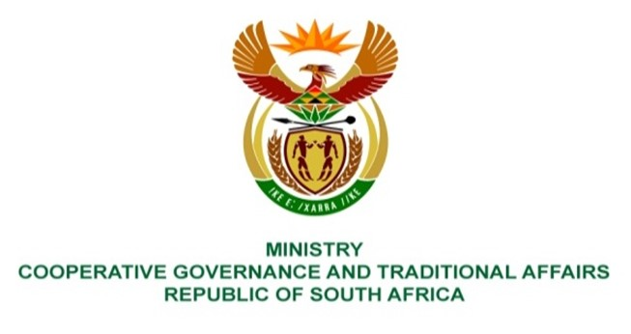

NATIONAL ASSEMBLY
WRITTEN REPLY

QUESTION NUMBER 4455
DATE OF PUBLICATION: 18 NOVEMBER 2022

QUESTION:

4455. Ms H O Mkhaliphi (EFF) to ask the Minister of Cooperative Governance and Traditional Affairs:
Whether her department keeps record of the total number and cost to municipalities of indigent households that are registered in databases for free basic services in each municipality; if not, why not; if so, what (a) was the total number of indigent households in each specified municipality and (b) total amount has each municipality spent on free basic services in the (i) 2019-20 and (ii) 2020-21 financial years? NW5583E

REPLY:

Yes, the Department keeps a record of the total number of indigent households and their cost to each municipality.

a) There is a total number of 3 580 006 indigent households for the 2019/20 financial year. There is no published data for the total number of indigent households for 2020/21 financial year, as the information is currently being consolidated. The breakdown per municipality is attached as Annexure A.

b) (i) (ii) The Department is currently monitoring the expenditure on free basic services through the Municipal Standard Chart of Accounts (mSCoA) initiative led by the National Treasury. The reported total amount spent on free basic services in 2019/20 was R5 240 830 709 and in 2020/21 was R5 985 622 950. The breakdown per municipality is attached as Annexure A.

