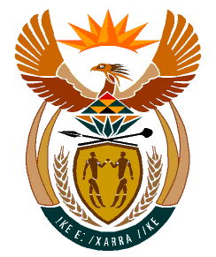

MINISTRY
HUMAN SETTLEMENTS
REPUBLIC OF SOUTH AFRICA

Private Bag X645, Pretoria, 0001. Tel: (012) 421 1309, Fax: (012) 341 8513

Private Bag X9029, Cape Town, 8000. Tel (021) 466 7603, Fax: (021) 466 3610

NATIONAL ASSEMBLY
QUESTION FOR WRITTEN REPLY
QUESTION NUMBER: PQ 4432
DATE OF PUBLICATION: 18 NOVEMBER 2022

Mrs C C S Motsepe (EFF) to ask the Minister of Human Settlements:

- On what date is it envisaged that adequate housing will be provided for residents of the Mzamo informal settlement in the Eastern Cape and

- What are the further relevant details in this regard?

REPLY
My Department in conjunction with the Eastern Cape Provincial Department of Human Settlements are not able to establish where the Mzamo informal settlement is hence I am not able to adequately respond to the Question. I therefore wish to request the Honourable Member to provide further details such as the municipal area or town where the Mzamo informal settlement is situated as this information will allow me to provide an adequate Reply to the Honourable Member’s Question.

