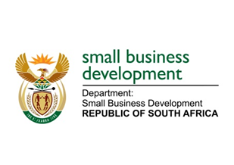

NATIONAL ASSEMBLY

QUESTION FOR WRITTEN REPLY

“443. Mr R W T Chance (DA) to ask the Minister of Small Business Development:

(1) With reference to her reply to oral question 336 on 4 December 2017, what is the (a) purpose of the position of Business Development Officer: Paper Chemicals and Plastics and (b) remuneration package for the specified position;

(2) whether the specified position has been advertised; if not, on what date will it be advertised; if so, (a) on what date was it advertised and (b) what are the further relevant details;

(3) whether the specified position has been filled; if not, on what date will it be filled; if so, what are the relevant details?”

NW460E

REPLY:

(1)(a) The purpose of the post is to process Development Finance Incentive applications and claims and make recommendations for approvals and payments. The title Business Development Officer: “Chemicals and Plastics” was incorrect as it was used by the Department of Trade and Industry (the dti) and therefore transferred as such to the Department of Small Business Development (DSBD). However, it has been amended and was advertised with the correct title of Business Development Officer in alignment with the DSBD job titles.

.

(b) Remuneration package: R385 543 per annum (all inclusive).

(2)(a) The Business Development Officer position was advertised on 24 November 2017.

(b) The position was advertised in the Public Service vacancies circular.

(3) Interviews for the Business Development Officer were concluded on 14 February 2018. Recommended candidate information was forwarded for background screening and feedback is expected on 16 March 2018.

