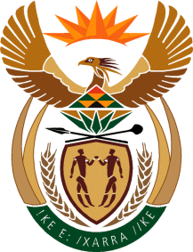

MINISTRY OF TOURISM
REPUBLIC OF SOUTH AFRICA

Private Bag X424, Pretoria, 0001, South Africa. Tel. (+27 12) 444 6780, Fax (+27 12) 444 7027
Private Bag X9154, Cape Town, 8000, South Africa. Tel. (+27 21) 469 5800, Fax: (+27 21) 465 3216

NATIONAL ASSEMBLY:

QUESTION FOR WRITTEN REPLY:
Question Number: 441
Date of Publication: 24 February 2023
NA IQP Number: 4
Date of reply:

Ms H Ismail (DA) to ask the Minister of Tourism:
a)(i) On what dates did certain board members of SA Tourism tender their resignations and (ii) by what date will the specified vacancies be filled and (b)(i) on what dates were and/or will the posts be advertised and (ii) by what date will the interviews take place? NW480E

REPLY:
I have been informed that:
(a) (i) Mr. Enver Duminy resigned on 1 February 2023, while Mr. Ravi Nadasen and Ms. Rosemary Anderson resigned on 2 February 2023.

– 2 February 2023

(ii) and (b) (i) and (ii)

On Friday 18 April, via a Government Gazette, I will dissolve the SA Tourism Board.

In the same Gazette, I will appoint three Interim Board members in terms of Section 16 (3) (b) of the Tourism Act with experience in Finance, Governance and Tourism.

These three members will have full decision-making powers until such time that the Board is officially appointed.

