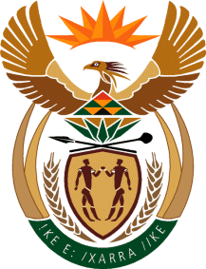

MINISTRY OF TOURISM
REPUBLIC OF SOUTH AFRICA

Private Bag X424, Pretoria, 0001, South Africa. Tel. (+27 12) 444 6780, Fax (+27 12) 444 7027
Private Bag X9154, Cape Town, 8000, South Africa. Tel. (+27 21) 469 5800, Fax: (+27 21) 465 3216

NATIONAL ASSEMBLY:

QUESTION FOR WRITTEN REPLY:
Question Number: 440
Date of Publication: 24 February 2023
NA IQP Number: 4
Date of reply:

Ms H Ismail (DA) to ask the Minister of Tourism:
Whether, with reference to the announcement of the resignation of three SA Tourism board members on 4 February 2023, the specified board members who resigned were (a) attending any of the meetings when the sponsorship deal was discussed, (b) part of the quorum when the sponsorship of the R1 billion was approved and (c) part of the decision-making process of the sponsorship to the English soccer club, Tottenham Hotspur; if not, why not, in each case; if so, what are the relevant details in each case? NW479E

REPLY:

- I have been informed by SA Tourism that all three members attended the Board meeting on 27 January 2023 where the Tottenham Hotspur proposal was first tabled for approval.

(b) I have been informed by SA Tourism that one board member attended the meeting and formed part of the quorum. The other two board members tendered their apologies and did not form part of the quorum.

(c) I have been informed by SA Tourism that one board member attended and recorded her dissent with regard to approval of the proposal. Another member, who tendered an apology for the meeting, formally submitted his disagreement and dissent in a letter to the Chairperson.

