MINISTRY IN ThE PR55IDEhCY: WOJBEN REPUBUC OF SOUTH AFRICA

PRIVATE BAG x 1000, PRETORIA, 0001, Tel: 082 877 2503

Memoandum born the Parliamen&ry O@ce
Minis&r

National Assembly quecfion for written reply: Ij-c/-

Date: @\(oi ( p ,y j q

Supportad /Net-6«ppodsd
1
, ,¿,«I¿»°-°

Ms!WR Tshabalala Deputy Director-Geneal Da&: -g§}o{tks II

Recommended /N

Ms AT Griessel
Acting Director-General
Da&: g,yg(( )

MINISTRY IN THE PRESIDENCY: WOMEN
REPUBLIC OF SOUTH AFRICA

NATIONAL ASSEMBLY QUESTION FOR WRITTEN REPLY QUESTION NUMBER: 44
DATE OF PUBLICATION IN INTERNAL QUESTION PAPER: 07 FEBRUARY 2019
INTERNAL QUESTION PAPER NUMBER: 01 - 2019

Ms M S Khawula (EFF) to ask the Minister of Women in the
Presidency:
Whether, in light of the e€orts to combat gender-based violence, her department intends to (a) introduce amendments to existing legislation and/or (b) propose any new legislation in order to curb the scourge of gender-based violence; if not, what is the position in this regard, if so, what are the relevant details? NW49E

Reply:
Government needs to adopt a transformative approach to programming for women’s access to justice. This includes developing interventions to challenge underlying socio-cultural norms and contexts of inequality that perpetuate discrimination

MINISTRY IN THE PRESIDENCY: WOMEN REPUBLIC OF SOUTH AFRICA

against women, enable and normalise Gender Based Violence (GBV) as we have recently seen with the Omotoso trial.
During the trial, the Department of Women (DOW) made a commitment to revisit the Sexual Offences Act, the Domestic Violence Act and the Criminal Procedures Act. This will be done in conjunction with the relevant lead department(s), in an e€ort to strengthen these laws in order to protect women.

The amendments will seek to invest in strengthening justice systems to investigate and prosecute Sexual and Gender Based Violence (SGBV) cases effectively; as well as invest in strengthening data collection systems, so that there is clarity on the extent and depth of the problem.

Domestic violence is currently not recorded by the police as a specific crime category; when cases of domestic violence are reported to the police, they are recorded under a range of diFerent categories such as assault, assault Grievous Bodily Harm (GBH), malicious damage to property, pointing a firearm, murder etc. In 2017/18 women were victims of the following:
- Murder 2930
- Total sexual offences 36 731

MINISTRY IN THE PRESIDEHCY: WOMEN REPUBLIC OF SOUTH AFRICA

- Attempted murder 3554
- Assault with intent to inflict grievous bodily harm 53 263
- Common assault 81 142
However, merely knowing the number of contact crimes perpetrated against women and/or children does not give us enough intormaGonto understandtheextentandcomplexiGesot domestic violence in South Africa. Even though the 2018 SAPS report indicates a list of domestic violence statistics, this is not the true reflection of the magnitude of domestic violence as most police stations still do not indicate a domestic relationship when cases of assault are reported. It has been estimated that abused woman stay in an abusive relationship for an average period of
10.5 years before seeking outside assistance.

Although the Domestic Violence Act 116 of 1998 requires police stations to record incidents of domestic violence in a register, compliance is minimal: the last compliance audit conducted by the Civilian Secretariat for Police (CSP) in 2014 found that only two of the 145 police stations under audit were fully compliant to the Act, a mere 1.40/ of the sample size.

MINISTRY IN THE PRESIDENCY: WOMEN REPUBLIC OF SOUTH AFRICA

South Africa played a historical role in pushing for the promotion and protection of the human rights of the lesbian, gay, bisexual, transgendered, and intersex, queer, asexual and other (LGBTIQA+) community. It is the first African country to recognise same sex marriages.
However, the LGBTIQA+ community in South Africa continue to experience widespread discrimination, harassment and violence, despite the Constitution guaranteeing their rights to safety; and regardless of sexual orientation or gender identity. Lesbians and gay men are raped to 'make them straight’ or to 'correct’ their sexual orientation. Although there are no accurate statistics for these hate-crimes, it is estimated that more than ten lesbians are raped or gang-raped weekly and at least 500 lesbians become victims of corrective rape annually. Once again, crimes of violence against LGBTIQA+ people are oXen under reported due to fear of secondary victimisation by the police and other service providers because of their sexual orientation. The government established a task team in 2011 to develop a legal framework to end violence and discrimination against LGBTIQA+ people. However, there is a lack of information regarding progress made by the task team and its programme and strategies to end this violence.

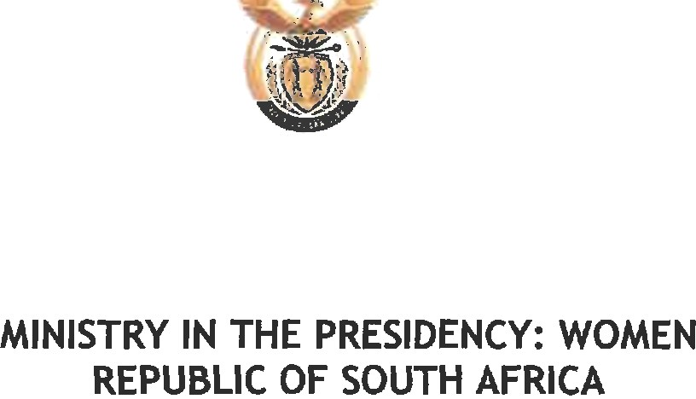

In trying to address Sexual and Gender Based Violence (SGBV), we need more detailed recording, analysis and dissemination of disaggregated statistics on sexual and domestic violence, so that SGBV can be tracked methodically and responded to e€ectively. There should also be a shift in focus from the reduction of sexual and domestic violence crimes reported to the police, to encouraging prevention, protection and reporting; and providing quality services to all victims of these crimes. This will necessitate a change in how police performance is measured.

The amendment of the above legislations to institute these changes is therefore necessary. Coupled with this, strategies to improve enforcement and to change social norms and attitudes need to be strengthened if we are to see effective improvement in the management of gender based violence.

Approved by the Minister on

MINISTRY IN THE PRESIDENCY: WOMEN REPUBLIC OF SOUTH AFRICA

