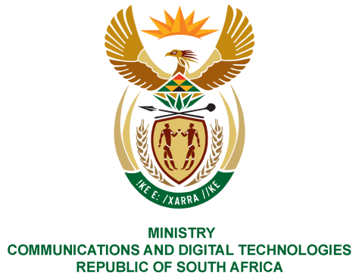

PARLIAMENT OF THE REPUBLIC OF SOUTH AFRICA
NATIONAL ASSEMBLY
WRITTEN REPLY

QUESTION NO: 439
DATE OF PUBLICATION: 13 March2020
QUESTION PAPER NO:9

Ms P T van Damme (DA) to ask the Minister of Communications:
Whether (a) she, (b) the Deputy Minister, (c) the Director-General and (d) any of the staff of her department (i) attended and/or (ii) accepted an invitation to attend and/or (iii) received tickets to the 2019 Rugby World Cup; if so, what are the relevant details including the (aa) names and positions of those who attended and (bb) breakdown of the amounts spent by her department on travel, accommodation, entertainment and any further specified expenses? NW620E

REPLY:

I have been advised by the Department as follows:

a - d). No

MS STELLA NDABENI-ABRAHAMS, MP
MINISTER OF COMMUNICATIONS AND DIGITAL TECHNOLOGIES

