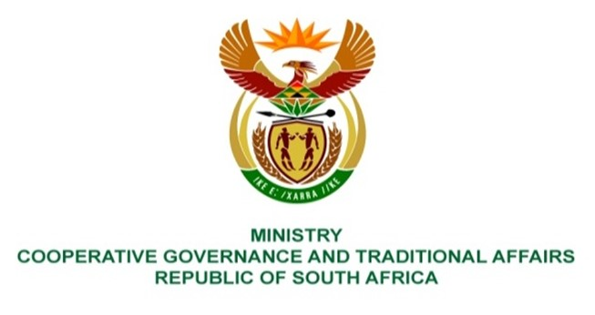

NATIONAL ASSEMBLY
WRITTEN

QUESTION NUMBER 4368
DATE OF PUBLICATION: 18 NOVEMBER 2022

QUESTION:

4368. Mr C Brink (DA) to ask the Minister of Cooperative Governance and Traditional Affairs:
What is the breakdown of municipalities in each province that use the executive (a) committee model and (b) mayor model? NW5492E

REPLY:

The table below provides a breakdown of the number of municipalities that utilises either the Collective Executive System or the Mayoral Executive System, per province:

NO. | PROVINCE | TYPE OF MUNICIPALITY
 |  | - Collective Executive System | - Mayoral Executive System
1. | Eastern Cape | 24 | 15
2. | Free State | 12 | 11
3. | Gauteng | 0 | 11
4. | KwaZulu-Natal | 54 | 0
5. | Limpopo | 21 | 6
6. | Mpumalanga | 0 | 20
7. | Northern Cape | 23 | 8
8. | North West | 13 | 9
9. | Western Cape | 0 | 30
TOTAL |  | 147 | 110

