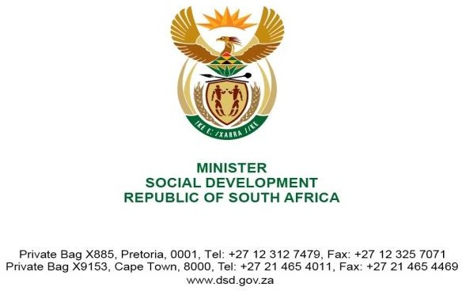

NATIONAL ASSEMBLY QUESTION FOR WRITTEN REPLY QUESTION NUMBER: 4350
DATE OF PUBLICATION IN INTERNAL QUESTION PAPER: 18 NOVEMBER 2022
INTERNAL QUESTION PAPER NUMBER: 49 - 2022

4350. Ms B S Masango (DA) to ask the Minister of Social Development:

How was the Chief Financial Officer of the SA Social Security Agency held accountable for the irregular expenditure incurred according to the 2021- 22 annual report? NW5474E

Response:

Kindly be advised that the Chief Financial Officer(CFO) has not been held accountable for the irregular expenditure;because in terms of the assessments and determinations undertaken in line with the Irregular Expenditure Framework,versions 2015 and 2018 it was other officials who were held liable for permitting/promoting irregular expenditure;and thus violating section 57 of the PFMA,1999.The identified officials have been subjected to the disciplinary processes in line with applicable labour laws.

Kindly also take note that the processes of dealing with irregular expenditure is not yet finalized; and should the assessment and determination currently underway happen to identify/implicate the CFO to have contributed or failed to prevent the irregular expenditure,the Agency will not hesitate to holding him accountable for his actions;

The current processes of dealing with the irregular expenditure and disciplinary proceedings are by nature very protracted; hence, the Agency has projected to finalize them on or before 31 March 2023.

