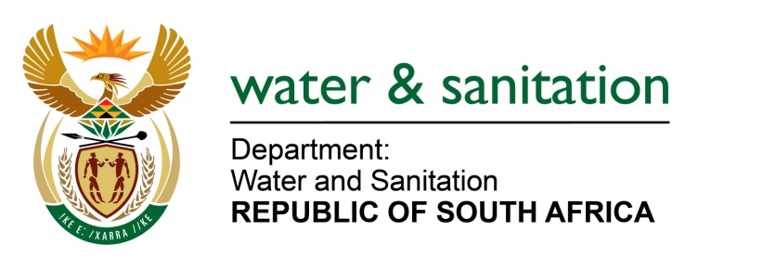

NATIONAL ASSEMBLY

FOR WRITTEN REPLY

QUESTION NO 4344

DATE OF PUBLICATION IN INTERNAL QUESTION PAPER: 18 NOVEMBER 2022
(INTERNAL QUESTION PAPER NO. 49)

4344. Ms A M van Zyl (DA) to ask the Minister of Water and Sanitation:
Whether his department has been informed of any sewerage spillages into natural water sources in the (a) Walter Sisulu Local Municipality and (b) Senqu Local Municipality; if not, what is the position in this regard; if so, what (i) is the location of each spillage and (ii) steps has his department taken to assist the Joe Gqabi District Municipality to (aa) fix the infrastructure and (bb) rehabilitate the specified natural water sources?
NW5468E
---00O00---

MINISTER OF WATER AND SANITATION

- The Department is aware of the sewage challenges experience by Joe Gqabi District Municipality. There have been long standing issues at the Burgersdorp sewage system and Steynsburg Waste Water Treatment Works (WWTW). The status regarding progress made is as follows:
- Contractors are currently at both sites
- Progress made at the Burgersdorp WWTW is at 95%
- Progress made with the Steynsburg sewage system is at 80%.

- (i) Site of pollution | (ii) (aa) steps taken by department to assist through repairs to the infrastructure | (ii) (bb) rehabilitation of the specified natural water sources
Burgersdorp - pollution of the Stormberg Spruit | - A directive had been issued and funding support was received from Municipal Infrastructure Grant and funding from Joe Gqabi DM  - Four (4) sewage pumpstations repaired as follows:  - repairs completed on 2 pumpstations  - repairs ongoing on 2 pumpstations and are in final stages, planned for completion at end November 2022. | Rehabilitation included removal of any paper and solids for burial and application of chloride of lime to disinfect affected areas
Steynsburg Sewage Ponds in the catchment of Teebus stream | - Funding support from Water Service Infrastructure Grant  - Project is about 80% complete with all work due to be completed by end February 2023. | Rehabilitation includes removal of papers, disinfection with chloride of lime and natural attenuation
Sterkspruit Activate Sludge Works | Sterkspruit Activate Sludge Works have been repaired and the works are functioning normally, thus removing the overload on the Sterkspruit Pond System | Overflow from the Sterkspruit sewage ponds had impacted the Sterkspruit Stream, but has since been resolved

---00O00---

