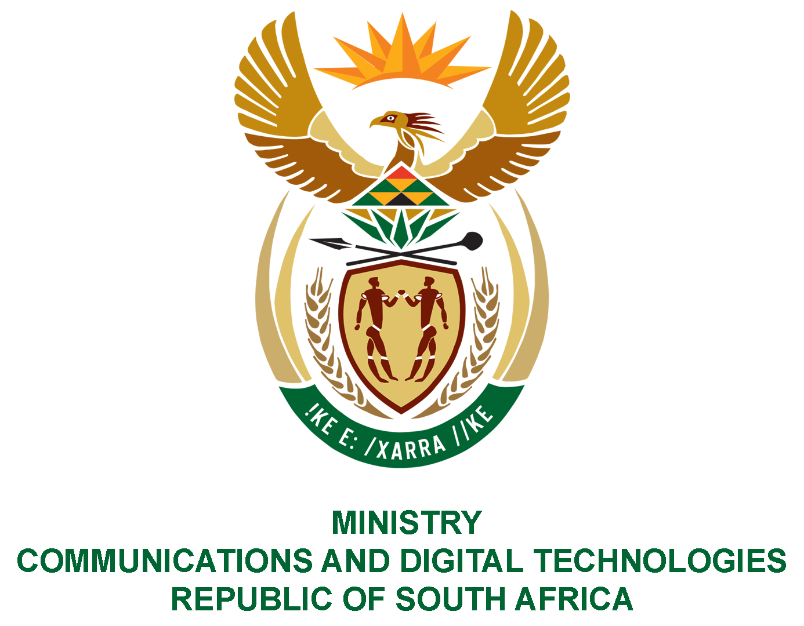

PARLIAMENT OF THE REPUBLIC OF SOUTH AFRICA

NATIONAL ASSEMBLY

WRITTEN REPLY

QUESTION: 431

DATE OF PUBLICATION: 25 FEBRUARY 2022
QUESTION PAPER NO: 04

Ms Z Majozi (IFP) to ask the Minister of Communications and Digital Technologies:
Whether, with reference to her statement during the debate on the State of the Nation Address on 15 February 2022 that an allocation of 10GB basic data would be made available to all households, and in view of the fact that the Republic is yet to complete its digital migration that was set in motion in 2006 and scheduled to be completed in 2015, a feasibility study and/or costing has been done for the proposed 10GB data roll-out; if not, why not; if so, what (a) are the full, relevant details and (b) is the proposed timeline for the roll-out? NW496E
REPLY:
I have been advised by the department as follows:

- A specific feasibility study relating to the 10GB data has not been undertaken, however, the SA Connect Phase 2 proposal borrows on the tenets of universal access to basic and essential services (e.g. water, electricity and data being the next step). Recognizing the negative impact of the digital divide, especially in the rural and underserviced areas, the statement relating to the allocation of 10GB is a statement of intent to address this divide.
- The proposed timeline is in parallel to the roll out of the SA Connect Revised Model, which is planned to be completed within the next 3 years starting from 01 April 2022.

