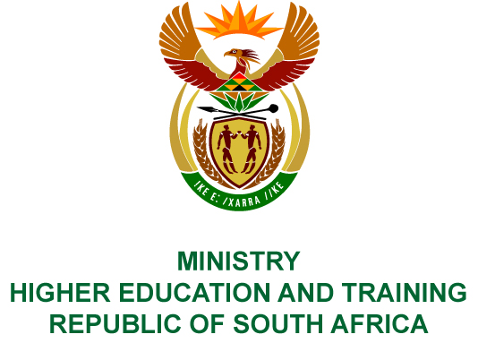
Private Bag X893, Pretoria, 0001, Tel (012) 312 5555, Fax (012) 323 5618
Private Bag X9192, Cape Town, 8000, Tel (021) 469 5150, Fax: (021) 465 7956
Memorandum from the Parliamentary Office
NATIONAL ASSEMBLY
FOR WRITTEN REPLY
QUESTION 431
DATE OF PUBLICATION OF INTERNAL QUESTION PAPER: 23/02/2018
(INTERNAL QUESTION PAPER NO 3 OF 2018)
Ms H Bucwa (DA) to ask the Minister of Higher Education and Training:
(1) Whether returning students have to (a) apply and (b) submit proof of household income annually for renewed support from the National Student Financial Aid Scheme (NSFAS); if not, what is the position in this regard; if so, why;
(2) By what percentage has the limit in household income to qualify for full support from the NSFAS been adjusted annually since its inception?
NW448E
REPLY:
- Returning students who applied for, and qualified for, funding through the National Student Financial Aid Scheme (NSFAS) in the 2017 academic year do not need to reapply for NSFAS funding in 2018. Students are not required to provide proof of family income annually. Once they have been selected for funding they will be supported to complete their qualification provided they continue to meet the academic requirements, i.e. have passed 50% of their courses and are on track to complete in n+2 years.
- The increase in percentage of combined household income to qualify for full support from NSFAS has been adjusted by 186.8% from R122 000 per annum in 2017 to R350 000 in 2018. This is the first time that the threshold in household income has been adjusted since the inception of NSFAS.

