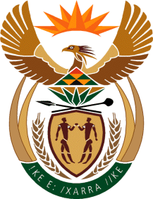

MINISTRY: COMMUNICATIONS
REPUBLIC OF SOUTH AFRICA
Private Bag X 745, Pretoria, 0001, Tel: +27 12 473 0164 Fax: +27 12 473 0585
Tshedimosetso House,1035 Francis Baard Street, Tshedimosetso House, Pretoria, 1000

NATIONAL ASSEMBLY
QUESTION FOR WRITTEN REPLY
QUESTION NUMBER: 429
DATE OF PUBLICATION: FEBRUARY 2016

Ms V van Dyk (DA) to ask the Minister of Communications:

(1) Whether the SA Broadcasting Corporation (SABC) has an audio bouquet; if not, why not; if so, (2) whether the specified audio bouquet will carry all of the SABC’s radio stations; if not, why not; if so, (3) whether any provisions have been made for community radio stations to be included in the specified bouquet; if not, (a) why not, and (b) how will advertisers be convinced to still advertise on community radio stations if the community radio stations are not broadcast nationally; if so, what are the relevant details? NW442E

REPLY: MINISTER OF COMMUNICATIONS
(1) Yes, the SABC has an audio bouquet, it currently sits on the DSTV bouquet

(2) Yes, all 19 SABC radio stations will be carried, this includes 15 PBS Radio stations, 3 PCS Radio stations as well as Channel Africa.

(3) Not yet, Community Broadcast Services will decide on how many TV and Radio services there will be on their portion of MUX1. All TV and Radio Services on DTT (SABC and Community) will also be available on the Direct to Home (DTH) Satellite platform that has a 100% National footprint.

MR NN MUNZHELELE
DIRECTOR GENERAL [ACTING]
DEPARTMENT OF COMMUNICATIONS
DATE:

MS AF MUTHAMBI (MP)
MINISTER OF COMMUNICATIONS
DATE:

