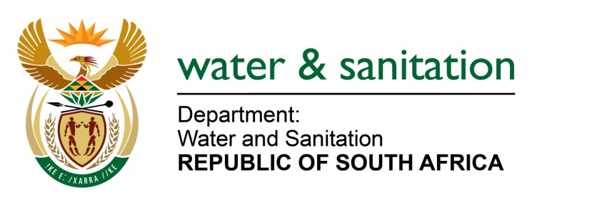

NATIONAL ASSEMBLY

FOR WRITTEN REPLY

QUESTION NO 4284

DATE OF PUBLICATION IN INTERNAL QUESTION PAPER: 11 NOVEMBER 2022
(INTERNAL QUESTION PAPER NO. 44)

4284. Mrs M R Mohlala (EFF) to ask the Minister of Water and Sanitation:
What (a) total number of resolutions has he implemented since the two-day National Water and Sanitation Summit that was held from 18 to 19 February 2022 at Gallagher Convention Centre in Midrand and (b) are the details of the specific milestones that have been reached?
NW5351E
---00O00---

MINISTER OF WATER AND SANITATION

The Summit was intended to engage various stakeholders together to form partnerships and identify lasting solutions to the water and sanitation problems facing the country. Based on the outcomes of the summit, the department is working together with SALGA, NT and COGTA, DWS will lead the development and implementation of a range of inter-related and coordinated support measures and interventions. Broadly, interventions that have been identified and are being implemented include the following:

  - Strengthening and extending the roles, responsibilities, and capacity of water boards so that they are able to provide water and sanitation services in instances where municipalities are failing to provide the services
  - Reviewing the geographical boundaries of the water boards to make them more sustainable, this already started with the disestablishment of Sedibeng Water
  - Increasing involvement of private sector financing and management in municipal water and sanitation services through public-private partnerships
  - Strengthening regulatory interventions based upon the results of monitoring mechanisms such as Blue Drop, Green Drop and No Drop
  - Strengthening the National Norms and Standards (Water Services Act) and put in place a framework to guide the provision of sanitation services
  - Introducing longer term interventions through WISP and the DDM programmes, through for example, taking over the management of wastewater treatment works from municipalities for a longer prescribed period where there is continued non-compliance with norms and standards
  - More effectively link the allocation of municipal water and sanitation grants to enable support and interventions
  - Use DWS internal construction capacity for rapid deployment to address urgent intervention needs
  - Put in place appropriate financing frameworks and mechanisms for support and interventions
  - Improve coordination and linkages of the interventions made in terms of sections of various legislation

Some of these measures will start to have an impact on municipal water and sanitation services in the short term (within 3 months) and others will yield results in the medium term.

---00O00---

