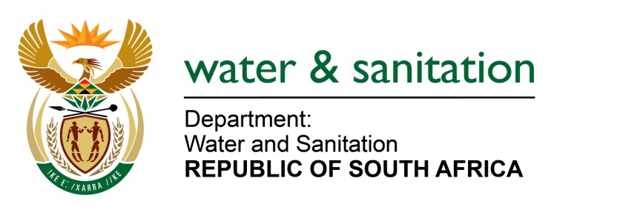

NATIONAL ASSEMBLY

FOR WRITTEN REPLY

QUESTION NO 4283

DATE OF PUBLICATION IN INTERNAL QUESTION PAPER: 11 NOVEMBER 2022
(INTERNAL QUESTION PAPER NO. 44)

4283. Mrs M R Mohlala (EFF) to ask the Minister of Water and Sanitation:
What is the (a) current backlog in the provision of water and sanitation in the rural areas across the Republic and (b) total cost attached to the backlog?

---00O00---

MINISTER OF WATER AND SANITATION

- The current backlog in the provision of water in the rural areas across the Republic are as follows:
- Out of a total of 19,368,622 households in South Africa 6 396 431 households are classified as rural households
- Out of 6 396 431 rural households 4 760 182 (86%) have access the RDP level of service for water
- Out of 6 396 431 rural households, only 3 157 091 (61%) have access to a reliable supply of water

- A funding gap of R33 billion must be closed each year for the next 10 years, through improved revenue generation and reduced costs based on a study undertaken through the National Water and Sanitation Master Plan (NWSMP). The department has embarked on the development of a Five-Year Reliable Water and Sanitation Services Delivery Implementation Plans that will, after completion, produce a pipeline of projects for each WSA with the associated costing. National grant funding programmes will be aligned with these needs.

---00O00---

