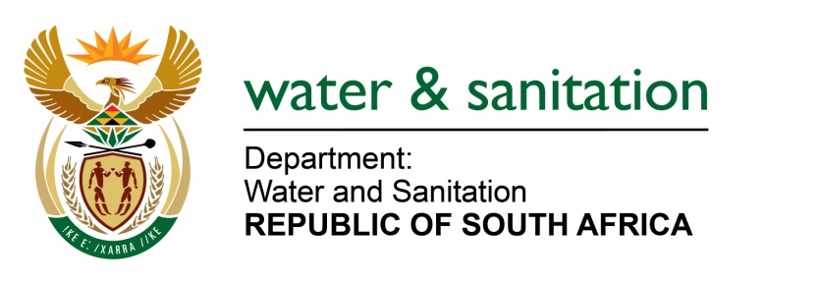

NATIONAL ASSEMBLY

FOR WRITTEN REPLY

QUESTION NO 4271

DATE OF PUBLICATION IN INTERNAL QUESTION PAPER: 11 NOVEMBER 2022
(INTERNAL QUESTION PAPER NO. 44)

4271. Mr T Mogale (EFF) to ask the Minister of Water and Sanitation:
What (a) has he found to be the prevalence of water shedding across the Republic and (b) are the causes thereof?
NW5338E
---00O00---

MINISTER OF WATER AND SANITATION
- Many of the provinces across the country have been impacted by a combination of factors including:
- Additional demand and water use owing to population growth and extension of services to previously unserved rural communities
- Prolonged droughts in certain parts of the country
- Shortage of bulk water (owing to droughts, delayed planning for and delivery of bulk water infrastructure such as dams and associated infrastructure)
- Challenges with municipal water service delivery
- Poor maintenance of municipal infrastructure that results in frequent pipe bursts and unreliable supply of water

To prevent more widespread water interruptions across the country, municipalities have resorted to water restrictions or even scheduled water interruptions to ensure that communities are able to access some water for a few hours.

- The main challenges impacting reliability of water supply are due to:
- Demand outstripping supply due to extensive growth of urban settlements
- Extension of services to previously unserviced rural settlements
- Poor maintenance of ageing infrastructure - at a municipal level - that has also reached the end of its lifespan
- Non-revenue water is currently at 45.1% (31,9 % refers to losses through physical leakages)
- The management of water treatment plants adds to the crisis as half of our treatment plants are operating below average standards and fully a third are critical based on the Blue Drop reports
- Ongoing load shedding by ESKOM during the last year has also intensified the situation by impeding the ability of Water Boards and municipalities to pump water into reservoirs. This resulted in water levels in the reservoirs being too low to gravity-feed water to high-lying areas across the country.

To address the challenges outlined above, the Department of Water and Sanitation (DWS) is in the process of:
- Planning and implementing a range of major projects to augment national bulk water resource infrastructure and
- Establishing the National Water Resource Infrastructure Agency (NWRIA) to finance and implement the large-scale investments in national water resource infrastructure that are required to ensure that South Africa has sufficient bulk water supply now and in future.
- Strengthening its role in supporting and intervening in municipalities where water and sanitation services are failing, in conjunction with provinces, COGTA, National Treasury and SALGA.
- The DWS has also developed the Water Services Improvement Programme (WSIP) to strengthen its support and intervention at municipal level based on actual data or most available data. The aim of the programme is for the Department to ensure that support and intervention at municipal level is proactive, consistent, and systematic.
- In line with the WSIP, the Department has further established the Water Partnership Office (WPO) within the Development Bank of Southern Africa (DBSA). The WPO has developed five standardized National Programmes for private sector participation in municipal water and sanitation services, to make it easier, quicker, and cheaper for municipalities to enter into partnerships, without having to ‘reinvent the wheel’ for each partnership. One of the five National Programmes within the WPO is Non- Revenue Water (NRW) programme aimed at implementing the Water Conservation and Water Demand Management and cost recovery programme focusing on reducing losses, reducing over consumption, and improving cost recovery

---00O00---

