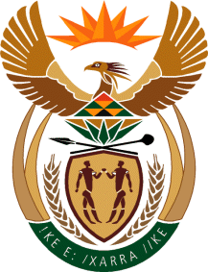

Ministry
Employment & Labour
Republic of South Africa
Private Bag X499, PRETORIA, 0001. Laboria House 215 Schoeman Street, PRETORA Tel: (012) 392 9620 Fax: 012 320 1942
Private Bag X9090, CAPE TOWN, 8000. 120 Plein Street, 12th Floor, CAPE TOWN Tel: (021) 466 7160 Fax 021 432 2830
www.labour.gov.za

NATIONAL ASSEMBLY

WRITTEN REPLY

QUESTION NUMBER: 427

[NW607E]

Dr M J Cardo (DA) to ask the Minister of Employment and Labour:

What number of (a) small-, (b) medium- and (c) micro-enterprises (i) applied for and (ii) received exemptions from the extension of collective bargaining agreements in (aa) 2017, (bb) 2018 and (cc) 2019?

Minister of Employment and Labour Reply:

Honourable Dr MJ Cardo, the bargaining councils furnished the Registrar of Labour Relations with the aggregated figures of exemptions from SMMEs. They classify them all under small business.
- For 2017, bargaining councils with extended collective bargaining to non-parties received from SMMEs a total of 1388 exemption applications. 1266 were granted; 91 were refused; and 17 were either withdrawn or still under consideration by end of 2017.

- For 2018, bargaining councils received from SMMEs a total of 2764 exemption applications. 2588 were granted; 114 were refused; and 93 were either withdrawn or still under consideration by end of 2018.

- In 2019, bargaining councils received from SMMEs a total of 1712 exemption applications, 1464 were granted; 168 were refused; and 76 were either withdrawn or still under consideration by end of 2019

