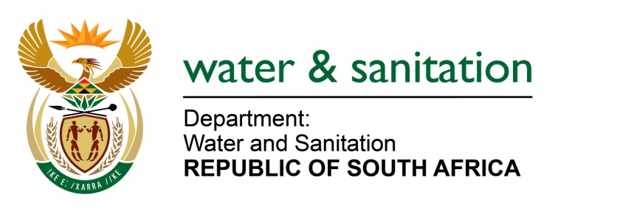

NATIONAL ASSEMBLY

FOR WRITTEN REPLY

QUESTION NO 4259

DATE OF PUBLICATION IN INTERNAL QUESTION PAPER: 11 NOVEMBER 2022
(INTERNAL QUESTION PAPER NO. 44)

4259. Ms A M Siwisa (EFF) to ask the Minister of Water and Sanitation:
With reference to his reply to question 753 for oral reply on 2 November 2022 pertaining to the eradication of pit toilets and bucket system and the completion of the projects, and noting that the residents of ward 17 in the Sol Plaatje Local Municipality are still left with half-built and/or dismantled toilets, leaving them with no privacy if they need to relieve themselves, (a) what are the reasons that the project is still not completed and (b) on what date will it resume as residents have been left stranded?
NW5326E

---00O00---

MINISTER OF WATER AND SANITATION

The sanitation project in the Sol-Plaatje Local Municipality, Ward 17 is being implemented in Phases. Phase 1 which provided 368 toilets was completed in September 2022. The issues listed above were primarily due to theft of material. In addition, the project was also affected by poor workmanship by the contractor compounded by labour unrest during implementation. The municipality is in the process of developing a business plan for funding of further phases.

---00O00---

