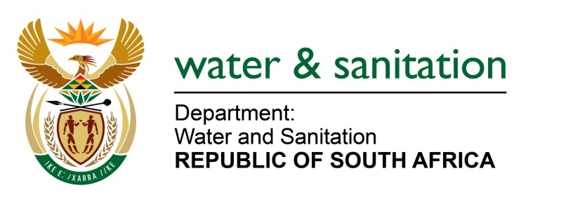

NATIONAL ASSEMBLY

FOR WRITTEN REPLY

QUESTION NO 4256

DATE OF PUBLICATION IN INTERNAL QUESTION PAPER: 11 NOVEMBER 2022
(INTERNAL QUESTION PAPER NO. 44)

4256. Mrs S M Mokgotho (EFF) to ask the Minister of Water and Sanitation:
What intervention has been made to ensure that the defects in the newly built houses of the community of Budeli, in Nandoni in the Vhembe district, who have been relocated from their area where the Nandoni dam is built are fixed?
NW5323E

---00O00---

MINISTER OF WATER AND SANITATION

The Budeli village is one of the five villages that the residents were affected by the construction of the Nandoni dam. A budget of R 62milllion has been set aside to repair the defects of all the five villages for the 2022/2023 financial year and the project is set to be completed by March 2023.

There were 100 houses that were found to have defects at the Budeli Village. Progress made by the Department is indicated below:

- Sixty-six (66) houses have been repaired
- One (1) house re-built due to the extent of the defects
- Repairs to the remaining thirty-three (33) houses will be completed by 15 December 2022.

---00O00---

