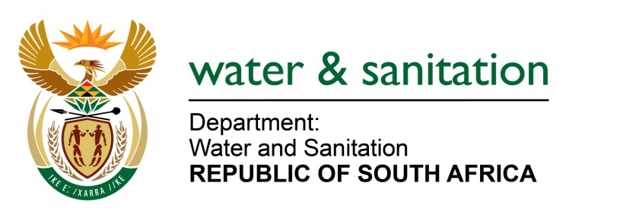

NATIONAL ASSEMBLY

FOR WRITTEN REPLY

QUESTION NO 4254

DATE OF PUBLICATION IN INTERNAL QUESTION PAPER: 30 NOVEMBER 2015
(INTERNAL QUESTION PAPER NO. 51)
4254. Mrs Z B N Balindlela (DA) to ask the Minister of Water and Sanitation:

(1) Whether any of the country’s metropolitan municipalities are currently treating effluent for reuse; if not, why not; if so, for each specified metro, (a) what percentage of effluent that passes through the treatment works is currently being reused, (b) how many of the wastewater treatment works are equipped to produce treated effluent for reuse and (c) for what purpose is the effluent being reused;

(2) whether she has taken any steps to encourage the recycling of effluent by municipalities; if not, why not; if so, what are the relevant details? NW5132E
---00O00---
REPLY:

(1) There are only Six (6) wastewater treatment works (WWTW) under the metropolitan municipalities reusing effluent. The following are WWTW that are currently treating effluent for reuse:

- eThekwini Metropolitan Municipality reuse wastewater treated at Durban Water Reclamation Plant;
- Buffalo City Metropolitan Municipality re-use wastewater treated at Eastbank WWTW;
- City of Tshwane Metropolitan Municipality re-use water at Baviaanspoort WWTW, Daspoort WWTW;
- Rooiwal WWTW; and
- Zeekoegat WWTW.

Refer to table below for the percentages and purpose of the effluent reused.
Name of Metro | Name of WWTW | Percentage of Re-use | Purpose of effluent reuse
eThekwini Metro | Durban Water Reclamation Plant | 100% | 100% of 47.5 Ml/d treated at Durban waste reclamation plant is being re-used.
Buffalo City Metro | Eastbank wastewater treatment works (WWTW) | 20% | 20% of 50 Ml/d treated at Eastbank WWTW is being reused
City of Tshwane Metro | Daspoort WWTW | 46.5% | Effluent from Daspoort WWTW flows via the Bon Accord Dam and used for agricultural irrigation. This agricultural use is not measured at point of abstraction by the Municipality.
 | Rooiwal WWTW | 49.4% | The effluent of the Rooiwal WWTWs used by the Rooiwal Power Station at a rate of 8.6ML/d. There is a long standing operational agreement that the neighbouring farmers must get 8ML/d and the average is currently at about 5ML/d.
 | Zeekoegat WWTW | 61.4% | The effluent from Zeekoegat WWTW is also used by a Dry Beans Seed Test Centrum (0.8ML/d)and the Agricultural Research Council (ARC) (0.6ML/d)
 | Baviaanspoort WWTW |  | Effluent re-use is with respect to internal use for process water and supply of treated effluent to the Pretoria Power Station for cooling purposes. Also it is estimated that a volume of 1.2 Ml/d being re-used for irrigation purposes for internal purposes only.
(2) My Department has encouraged recycling of effluent by municipalities more especially in water stressed areas of our country. Recently Lephalale LM has signed a contract with Resource Generation, which plans to open Boikarabelo Mine in Limpopo. Under the terms of the agreement, Resource Generation will build, operate and maintain a wastewater treatment facility at Marapong for the Boikarabelo mine site. The treated water will be pumped to the firm's planned Boikarabelo mine site through a new pipeline. Resource Generation will pay for the Marapong wastewater treatment plant upgrade works and expansion works to extend capacity to 4Ml a day, increasing to a daily 16Ml by January 2017.
Also in Lephalale, Waterberg Coal Company entered into an agreement with the Lephalale Municipal Council (LMC) to take over the management and operation of the Paarl WWTW for the purposes of supplying water to the Waterberg Coal Projects (WCP). The facility has a treatment capacity of 10 million litres per day.
---00O00---

