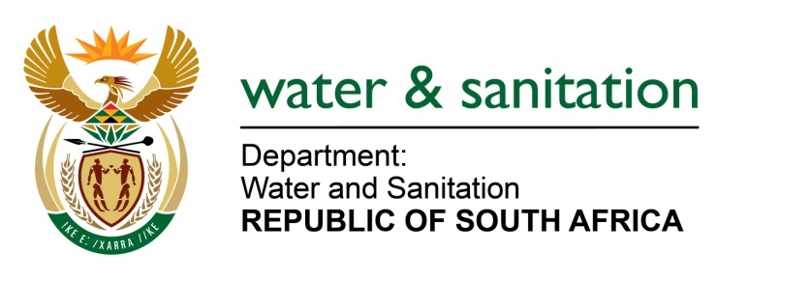

NATIONAL ASSEMBLY

FOR WRITTEN REPLY

QUESTION NO 4249

DATE OF PUBLICATION IN INTERNAL QUESTION PAPER: 30 NOVEMBER 2015
(INTERNAL QUESTION PAPER NO. 51)
4249. Mr M Waters (DA) to ask the Minister of Water and Sanitation:
Whether any Rand Water pump stations that feed water to any part of the Ekurhuleni Metropolitan Municipality in Gauteng experienced any power outages (a) in (i) August, (ii) September and (iii) October and (b) from 1 November 2015 up to the latest specified date for which information is available; if not, what is the position in this regard; if so, (aa) on which dates were power outages experienced, (bb) what was the length of time of each power outage, (cc) which pump stations were affected in each specified case and (dd) what was the effect on the supply of water to Ekurhuleni in each case? NW5127E
---00O00---
REPLY:
(a)(i)August 2015 | (a)(ii)  September 2015 | (a)(iii) October 2015 | (b) November 2015 | (b)(aa) days where power outages experienced | (b)(bb) length of time of each power outage | (b)(cc) pump stations affected | (b)(dd) effect on the supply of water to Ekurhuleni
None | None | Power outages occurred | None | None | 135 minutes | Mapleton Pump station. | None

---00O00---

