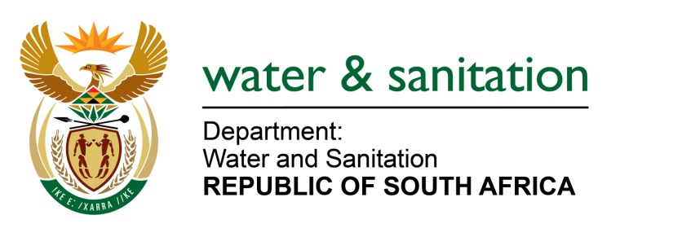

NATIONAL ASSEMBLY

FOR WRITTEN REPLY

QUESTION NO 4233

DATE OF PUBLICATION IN INTERNAL QUESTION PAPER: 11 NOVEMBER 2022
(INTERNAL QUESTION PAPER NO. 44)

4233. Ms S A Buthelezi (IFP) to ask the Minister of Water and Sanitation:
(1) Whether his department has implemented plans to address the serious risks posed to the citizens by the failing water treatment plants in KwaZulu-Natal; if not, why not; if so, what are the relevant details.
(2) whether his department will make funds available for the reconstruction of critical infrastructure which was damaged in the floods; if not, why not; if so, what are the relevant details:

---00O00---

MINISTER OF WATER AND SANITATION
- The Department of Water and Sanitation (DWS) conducted the Green Drop assessment during 2021/22 which culminated in the release of the National Green Drop Report 2022. In KZN, 14 Water Services Authorities (WSAs) and 147 wastewater systems were audited with the following results

- 47 of the wastewater systems in KwaZulu Natal were found not to be measuring their wastewater inflows
- 7 wastewater systems were overloaded
- 76 wastewater systems received Green Drop Score of above 50% (meaning what?)
- 20 wastewater systems were found to be at critical state
- 3 wastewater systems received Green Drop certification (scored minimum of 90%).

To mitigate the risk, the DWS has implemented several interventions including the issuance of non-compliance letters, notices, and directives to minimize the pollution impacts on the water resources. In addition, corrective action plans and green drop improvement plan templates have been issued to the WSAs to ensure that their Councils commit funds to address the gaps identified in the assessments. The DWS is assisting the WSAs to compile corrective action plans and improvement plans which will need to be implemented within predetermined timeframe and monitored by the department.
The department has also implemented measures to address pollution of water resources in KwaZulu-Natal. These include:
- Undertaking routine inspections of sewerage infrastructure (wastewater treatment works, pumpstations and pipelines).
- The DWS also follows up on pollution issues reported by the public.
- In cases where pollution to water resources is observed, administrative processes are taken against the non-compliant municipalities in the form of Non-compliance Notices and/or Directives
- The Department has also established Water Resource Protection Technical Committee Meetings to address the issues of pollution in different districts
Following the floods in April 2022, the DWS has also implemented the following interventions to support affected municipalities in KZN:
- Availed the team of Engineers and Scientists to assist with the assessments of the damage to the water and sanitation infrastructure
- Officials of the department participate in WAR Room meetings where repairs of infrastructure and progress thereof are discussed
- Three (3) Directives were issued, on 13 May 2022, to the municipalities which were severely affected, namely: eThekwini Metropolitan Municipality, ILembe District Municipality (DM) and Ugu DM
- Established the WAR Room through the Minister to address issues of water provisioning and sanitation, as well as to discuss challenges that the municipalities might be facing such as funding, human resources, amongst others

(2) The DWS assisted the Ethekwini, Ugu and Ilembe District Municipalities by reallocating R65 million funding to support immediate relief measures which included provision water tankers for 3 months. The DWS also conducted assessments of the damaged infrastructure and submitted a funding application for disaster relief funding to the National Disaster Management Centre. Damaged infrastructure can also be repaired through reprioritising of the DWS Water and Sanitation Infrastructure Grant (WSIG).

---00O00---

