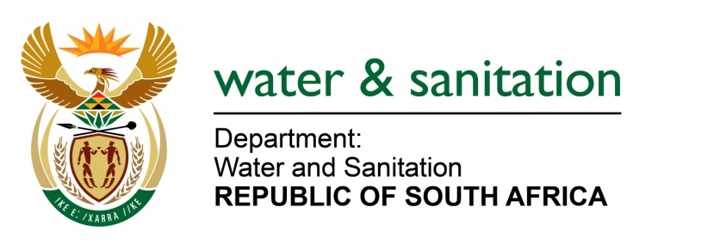

NATIONAL ASSEMBLY

FOR WRITTEN REPLY

QUESTION NO 4230

DATE OF PUBLICATION IN INTERNAL QUESTION PAPER: 30 NOVEMBER 2015
(INTERNAL QUESTION PAPER NO. 51)
4230. Ms T Gqada (DA) to ask the Minister of Water and Sanitation:

(1) Whether, with regard to the ongoing non-functioning waste water treatment plants in the towns of Embalenhle, Leandra and Bethal in the Govan Mbeki Local Municipality in Mpumalanga, her department has taken any steps in line with the National Water Act, Act 36 of 1998, against the specified municipality for polluting the environment as a result of continuous sewerage spills; if not, why not; if so, in each case, what are the (a) relevant details of the specified action and (b) dates on which the specified action was taken;

(2) what is the extent of the damage to the environment and particularly the effect on the Vaal River system which the streams from these waste water plants flow into;
(3) what health hazards have the communities of the specified towns been exposed to asa result of the close proximity of residential settlements to the specified plants? NW5107E
---00O00---
REPLY:

(1) Yes, my Department has taken steps in line with the National Water Act, Act 36 of 1998 against Govan Mbeki Local Municipality in terms of Section 19 to ensure that pollution or potential pollution does not have a detrimental impact on water resources.

(1)(a) A “notice of intention to issue a directive” and a “directive” (all in terms of Section 19 of the NWA) were issued to Govan Mbeki Local Municipality for pollution incidents as per Table 1 below.

Table 1
Name | Relevant details | Date issued
A directive was issued to Bethal Wastewater Treatment Works | Sewerage spills associated with pump stations failures. A task team was established with other relevant Departments such as (Department of Corporative Governance and Traditional Affairs, Human Settlements and Gert Sibande District Municipality to monitor progress on the plan required as per the directive. Currently all the pump stations are operational. | 13 January 2013
A notice was issued to Embalenhle Wastewater Treatment Works | Sewerage spills associated with pump stations failures. The plant is currently being refurbished to cater for an extra load. | 01 September 2015

(1)(b) See relevant dates as provided in Table 1.

(2) My Department does not allow effluent from being discharged to the environment before being suitably treated. The water quality in the Vaal River system is slightly affected as the current infrastructure of the wastewater treatment works has aged, overloaded and there is lack of maintenance. My Department is responding to this threat by implementing programmes such as Regional Bulk Infrastructure Grant. Municipal Water Infrastructure Grant and Accelerated Infrastructure Programme. In addition, the Green Drop reports are compiled annually to provide an indication on the level of compliance of wastewater treatment works and whether conditions of authorisation are met.

(3) There are no health hazards which have been exposed to the communities of the specified towns as the sewerage spills have been localised and the areas rehabilitated speedily after the municipality was notified. In addition, no water is drawn from the adjacent rivers by the communities as potable water is provided by the municipality. Furthermore, my Department’s ongoing regulation and enforcement measures will ensure that any current and future wastewater impacts on the water resources are adequately addressed.
---00O00---

