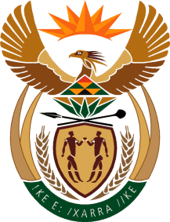

MINISTRY OF TOURISM
REPUBLIC OF SOUTH AFRICA

Private Bag X424, Pretoria, 0001, South Africa. Tel. (+27 12) 444 6780, Fax (+27 12) 444 7027
Private Bag X9154, Cape Town, 8000, South Africa. Tel. (+27 21) 469 5800, Fax: (+27 21) 465 3216

NATIONAL ASSEMBLY:

QUESTION FOR WRITTEN REPLY:
Question Number: 423
Date of Publication: 13 March 2020
NA IQP Number: 9
Date of reply: 30 April 2020

Mr M S F De Freitas (DA) to ask the Minister of Tourism:
With reference to the SA Tourism Board Assessment Reviews, (a) what reviews have been initiated, (b) on what dates did the specified reviews (i) commence and (ii) conclude, (c) what was the outcome of each review, (d) what (i) were the recommendations in each case and (ii) was the reason for each specified recommendation, (e) what (i) recommendation was implemented as a result of such reviews in each case and (ii) was the reason for each such implementation and (f) how is the process being monitored in each case? NW603E
Reply:

(a)What reviews have been initiated?
The Board conducted an independent evaluation of its effectiveness based on the Board Charter and
King IV best practice recommendations.

(b) On what dates did the specified reviews
(i) commence: September 2019
(ii) Report submitted to the Board: February 2020

(c) What was the outcome of each review?
The Minister is yet to receive a final report adopted by the board.

(d) What (i) were the recommendations in each case?
The final report with adopted recommendations has not yet been submitted to the Minister.

(d) (ii) What was the reason for each specified recommendation?
Not yet applicable

(e) what (i) recommendation was implemented as a result of such reviews in each case and
Not yet applicable

(e) (ii) was the reason for each such implementation and
Not yet applicable

(f) how is the process being monitored in each case?
Not yet applicable

