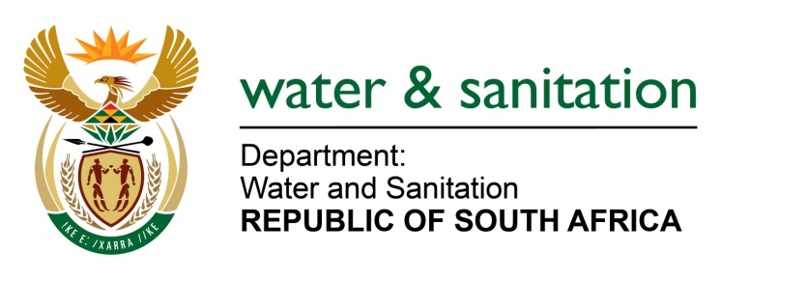

NATIONAL ASSEMBLY

FOR WRITTEN REPLY

QUESTION NO 4229

DATE OF PUBLICATION IN INTERNAL QUESTION PAPER: 30 NOVEMBER 2015
(INTERNAL QUESTION PAPER NO. 51)

4229. Ms T Gqada (DA) to ask the Minister of Water and Sanitation:

(1) (a) What are the reasons for the frequent interruptions of the water supply to Delmas in the Victor Khanye Local Municipality in Mpumalanga, (b) what action is being taken to remedy the situation and (c) by what date will the water supply be stabilised;

(2) whether she has taken any action against the specified municipality for the violation of the rights of the residents of Delmas to have access to water as enshrined in the Bill of Rights; if not, why not; if so, what are the relevant details? NW5106E

---00O00---
REPLY:

(1)(a) The reasons for the water supply interruptions to Delmas is due to the following:
- Breakages of the pipeline ageing of bulk water pipe line which was made of Asbestos in Sundra, Rietkol and Eloff.
- Increasing of the pipeline size to increase the volume of water supply in Boetleng.

(1)(b) Remedial actions are as follows:
- With regards to the Sundra, Rietkol and Eloff areas, the Municipality has made a request to the Provincial Co-operative Governance and Traditional Affairs(COGTA) for the replacement of the Asbestos Pipeline that will be at an amount of R120000 000.
- In terms of the Boetleng area, water has been restored and the community is receiving water without any interruptions.

(1)(c) The date which water supply stabilisation in Victor Khanye will be determined by the outcome of the request submission which has been made to the Provincial COGTA.

(2) As indicated above, the temporary disruptions are an unintended consequence of government efforts to redeem the state of infrastructure within the municipality consequently reducing the risk of breakdowns in future. There is regular liaison with the residents on these infrastructure upgrades. Considering that there is no undue intention to deprive residents of their basic rights, my Department supports the infrastructure upgrades. Naturally, most major infrastructure upgrades may render temporary disruptions; these are intended for the good of all residents concerned. Other than supporting the good cause the Department of Water and Sanitation (DWS) does not deem necessary to pursue action against the municipality at this stage. The DWS will work together with the municipality to ensure that the process is carried out in a manner that will bring reduced impact to the residents.
---00O00---

