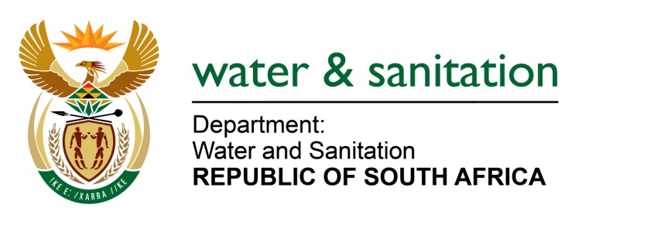

NATIONAL ASSEMBLY

FOR WRITTEN REPLY

QUESTION NO 4227

DATE OF PUBLICATION IN INTERNAL QUESTION PAPER: 30 NOVEMBER 2015
(INTERNAL QUESTION PAPER NO. 51)
4227. Ms T E Baker (DA) to ask the Minister of Water and Sanitation:
(a) Which municipalities in Mpumalanga are at risk due to poor water quality, (b) what is the cause of the risk and (c) what action has been taken to resolve the risks? NW5104E
---00O00---
REPLY:

(a) The municipalities in Mpumalanga that are at risk are located within Ehlanzeni, Gert Sibande and Nkangala District Municipalities. Intervention put in place by my Department are as follows:
- Training on Blue drop compliance;
- Bulk infrastructure and Water Treatment plant upgrades were necessary;
- Technical Support;
- Water Quality Monitoring programme;
- Development to incident Management and response protocol.

---00O00---

