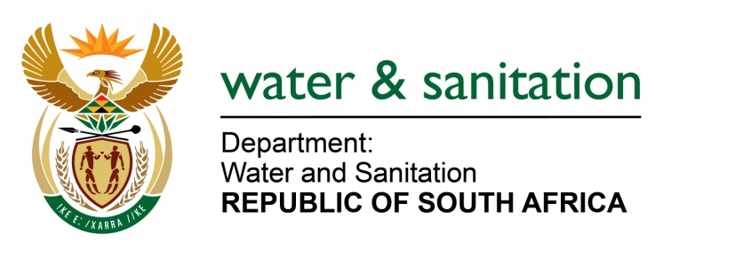

NATIONAL ASSEMBLY

FOR WRITTEN REPLY

QUESTION NO 4226

DATE OF PUBLICATION IN INTERNAL QUESTION PAPER: 30 NOVEMBER 2015
(INTERNAL QUESTION PAPER NO. 51)
4226. Ms T E Baker (DA) to ask the Minister of Water and Sanitation:
What is the supply and demand ratio for each municipality that is supplied with water by each water board in each province? NW5103E
---00O00---
REPLY:

Refer below for the supply and demand ration for each municipality supplied by each water board.

Water Board | Municipality | Supply and Demand Ratio
Amatola Water | Amathole District Municipality | 6.49%
 | Buffalo City Metropolitan Municipality | 6.28%
 | Ndlambe | 6.22%
Bloem Water | MangaungMetropolitan Municipality | 91%
 | Naledi Local Municipality | 2%
 | Kopanong Local Municipality | 6%
 | Mantsopa Local Municipality | 1%
Lepelle Northern Water | Polokwane Municipality | 1:1,4%
 | Mogalakwena Municipality | 1:1,09%
 | Ba-Phalaborwa Municipality | 1,41:1%
 | Greater Letaba Municipality | 1: 1,7%
 | Greater Tzaneen Municipality | 1:1,3%
 | Elias Motswaledi/Fetakgomo/Makhuduthamaga municipalities | 1,1:1%
 | Tubatse Municipality | 1:1,75%
 | Ephraim Mogale Municipality | 1:0,85%
Magalies Water | Bela-Bela Local Municipality | 81%
 | City of Tshwane Metro | 44%
 | ModimolleLocal Municipality | 93%
 | Moses Kotane Local Municipality | 132%
 | Rustenburg Local Municipality | 135%
 | Thabazimbi Local Municipality | 126%
Mhlathuze Water | City of uMhlathuze | 1:1%
 | UThungulu | 0,1:1%
Overberg Water | The Municipalities supplied are Theewaterskloof and Hessequa in the Western Cape. % cannot be provided per Municipality as the water schemes do not only provide to Municipalities, but also for agricultural customers. Below are schemes
 | Duivenhoks | 63.96%
 | Ruensveld East | 44.21%
 | Ruensveld West | 61.11%
Rand Water | Johannesburg Water | 1,784%
 | Ekurhuleni | 1,185%
 | City Of Tshwane Metropolitan Municipality | 864%
 | Emfuleni | 301%
 | Mogale City Municipality | 96%
 | Metsimaholo Local Municipality | 58%
 | Rustenburg Municipality | 113%
 | Govan Mbeki Municipality | 77%
 | Midvaal | 32%
 | Merafong | 88%
 | Randfontein Municipality | 32%
 | Westonaria Local Municipality | 51%
 | Lesedi Local Municipality | 22%
 | Ngwathe Local Municipality - Heilbron Town  Council | 8%
 | Delmas Local Municipality | 17%
 | Royal Bafokeng Nation | 20%
 | Madibeng Local Municipality | 12%
 | Thembisile Local Municipality | 39%
Sedibeng Water Free State | Matjhabeng | 1,79%
 | Nala | 1,79%
 | Maquassi Hills | 1,79%
Sedibeng Water Northern Cape | Dikgatlong LM | 1,3%
 | Tsantsabane LM | 1,3%
 | Gamagara LM | 1,3%
 | Joe Morolong LM | 1,4%
 | NamaKhoi LM | 1,3%
 | Khai Ma LM | 1,5%
Sedibeng Water North West Ngaka Modiri Molema District Municipality | Mahikeng | 1,10%
 | Ditsobotla | 1,16%
 | RamotshereMoiloa | 1,13%
Umgeni Water | eThekwini Municipality | 99%
 | Msunduzi Municipality | 100%
 | uMgungundlovu District Municipality | 89%
 | iLembe District Municipality | 8%
 | uGu District Municipality | 100%
 | Harry Gwala District Municipality | 89%

---00O00---

