NATIONAL ASSEMBLY

56/1/4/1(202100045)

FOR WRITTEN REPLY

UES ON

DATE OF PUBLICATION IN INTERNAL QUESTION PAPER: 26 FEBRUARY 2021
(INTERNAL QUESTION PAPER NO 4-2021)

M2. Ms Z Msjozi (IFP) to ask the Minister of Police: [650] [Question submitted for oral reply now placed for written reply because It Is in excess of quota (Rule 137(8))]

- What have been the findings of the task team he appointed to investigate stock theft in the Free State amid an increase in the crime which he described as eConomic sabotage;

- whether there are plans to appoint the same and/or similar task team in other parts of the Republic where there is a similar problem; if not, why not; if so, what are the further relevant details?

REPLY:
NW470E

- During the intervention it was discovered that the Stock Then lnfomation Centre was not in place. The following government departments and organisations are represented in the Stock Theft lnfomation Centre:
  - The Department of Agriculture, Land Refom and Rural Development.
  - The South African Police Service (SAPS) Stock Theft and Endangered Species Units.
  - Red Meat Organisations.
a The Nafional Prosecuting Authority (NPA).
- Live Stock Farmers, National Agricukural Farmers Union (NAFU).
- Transvaal Agricultural Union (TAU).

The purpose of the Stock Theft lnfomation Centre, is as follbws:
- The sharing of intelligence between communities and detectives.
- Providing feedback, with regard to stock theft cases.
- Creating community awareness, with regard to relevant legislation, e.g. the Animal Identification Act, the Stock Theft Act and the Meat Safety Act, etc.
- Joint visits to livestock and meat disposal points.
- Discouraging the community not to mediate serious stock theft court cases.

- The SAPS 1s continuously monitoring the stock theft trends and where a similar trend is noticed, various approaches are put in place after analysing the facts. There are currently four task teams operating in identified stock theft hotspots in the Eastern Cape and KwaZulu-Natal, in various districts.

Reply to question 422 recommended/

GENERAL
IO
NJ
CO
E (SOEG)
E
0
H AFRICAN POLICE SERVICE

Reply to question 422 approved/ pp o ed

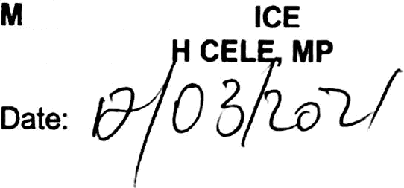

US FPOL GENERALB

