FOR WRITTEN REPLY QUESTION 422

NATIONAL ASSEMBLY
36/1/4/1(2019)

DATE OF PUBLICATION IN INTERNAL QUESTION PAPER: 1 MARCH 2019 (INTERNAL UESTION PAPER NO 5-2019)

422. Mr M G P Lekota (Cope) to ask the Minister of Police:

Whether the Government intends to continue with its non-statutory forces project; if so, (a) what criteria is being applied to determine the promotions to be effected in terms of the programme and (b) how will (i) these promotions be effected in a fair, meritorious and transparent manner given the rights and aspirations of other members of the SA Police Service and (ii) this programme assist in advancing the need to boost the professionalism and capacity of the organisation?
NW485E

REPLY:
(1) The continuation of the South African Police Service Non Statutory Forces (SAPS NSF) project is currently the subject of a review application which was brought against the South African Police Service by the Solidarity Union in the Gauteng North High Court. An interdict prohibits the South African Police Service to continue with the SAPS NSF project pending the outcome of Solidarity Union’s review application. Once the review application is finalised, a clear Judicial directive will be issued as a court order in this regard.

- , LIEUTENANT GENERAL D ISIONAL COMMISSIONER: PERSONNEL MANAGEMENT
NTSHIEA

Date: \ ’ ” ‘

Reply to question 422 recommended
DEP

BC MGWENYA

LIEUTENANT GENERAL MMISSIONER: HUMAN RESOURCE MANAGEMENT

Reply to question 422 recommended d

AL
OLE (SOEG)
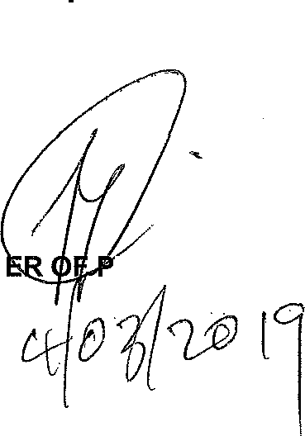
Date: › ‹J- 0 I

GENERAL SIO ?SOUTH AFRICAN POLICE SERVICE

Reply to question 422 approved/nopgeds

MINIST BH CELE

Date:

OLICE

