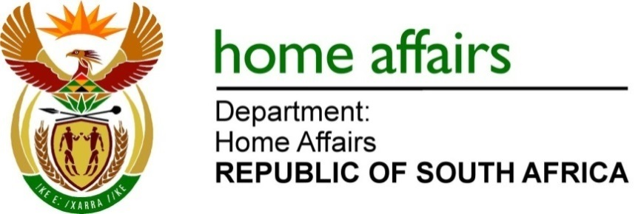

NATIONAL ASSEMBLY

QUESTION FOR WRITTEN REPLY

QUESTION NO. 4217

DATE OF PUBLICATION: FRIDAY 11 NOVEMBER 2022

INTERNAL QUESTION PAPER 47 – 2022

4217. The Leader of the Opposition (DA) to ask the Minister of Home Affairs:

Whether he will furnish the Leader of the Opposition with a list of all South Africans who are in possession of a diplomatic passport; if not, what is the position in this regard; if so, what are the relevant details? NW5283E

REPLY:
The Honourable Member is herewith informed that Diplomatic passports are issued according to the South African Diplomatic Passport Policy and that the Department of Home Affairs is not the custodian of this policy, and similarly not responsible for the application(s) as well as the issuance of this category of passports whatsoever. Hence it is requested that any information relating to Diplomatic Passports should be addressed to the Department of International Relations and Co-operation (DIRCO).

END

