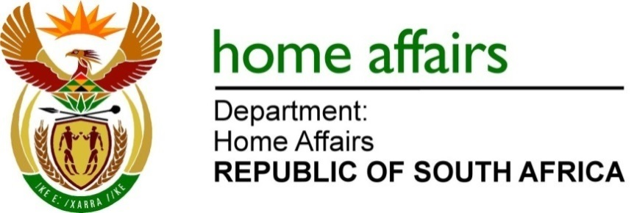

NATIONAL ASSEMBLY

QUESTION FOR WRITTEN REPLY

QUESTION NO. 4208

DATE OF PUBLICATION: FRIDAY 11 NOVEMBER 2022

INTERNAL QUESTION PAPER 47 – 2022

4208. Mr A C Roos (DA) to ask the Minister of Home Affairs:

In light of the fact that the SA High Commission Canada charges CAN$127 for a passport and CAN$253 for a maxi passport and the SA High Commission New Zealand charges NZ$135 for a passport and NZ$270 for a maxi passport, what are the reasons that (a) the prices are far higher than the R1 200 for a passport and R2 400 for a maxi passport advertised on 1 November 2022, (b) non-first-time United Kingdom (UK) applicants pay the equivalent of R1 200 for a passport and R2 400 for a maxi passport when they are forced to pay an additional GBP35 to apply through Visa Facilitation Services Global and (c) non-first-time UK applicants do not have the option to apply directly at the SA High Commission? NW5274E

REPLY:
- New passport and travel document tariffs were gazetted in the Government Gazette No. 47256 dated 9 September 2022. In accordance with this Gazette, the tariff for a normal 32-page adult and child passport applied for at a South African mission is R1 200.00 while the tariff for a maxi passport applied for at a South African mission is R2 400.00. These new tariffs became effective 1 November 2022.

The missions were informed of the new tariffs for passports and travel documents under cover Revenue Circular No. 6 of 2022, dated 31 October 2022. In this regard, the missions were informed of the ‘spot rate’ to be used in instances where the tariff needs to be converted into a foreign currency. Using these ‘spot rates’ for Canada, New Zealand and the United Kingdom, the indicative prices for normal 32-page passports and maxi passports should be as per the table below:

Country | Spot rate | 32 page passport | Maxi passport
Canada | 0.0753383665 | CAD91.00 | CAD181.00
New Zealand | 0.095299378 | NZD115.00 | NZD230.00
United Kingdom | 0.047938754 | GBP58.00 | GBP116.00

Spot rates are used to ensure consistency in the applicable exchange rate. The Department therefore does not vary tariffs payable at the missions on a daily basis as the exchange rates fluctuate. The prices at the missions are rounded up to eliminate the need for change.

The mission in Canada applied the wrong spot rate and did not immediately update its webpage with the correct amounts for Canadian dollars. This oversight has been rectified and the current rates for passports as per the website is the following:

Adult / child passports (32 pages): CAD91:00 (http:///www.southafrica-canada.ca/regular-south-african-passports-c55-processing-fee/ )

Maxi passport (48 pages): CAD181 (http://www.southafrica-canada.ca/maxi-passports/ )

The mission in New Zealand also applied the wrong spot rate. This mission was requested to update its webpage with the correct amounts, in New Zealand dollars, for South African passports applied for at the mission.

- The introduction of a passport pilot project in the UK through VFS was as a result of high volumes of applications and over six to nine months turnaround times with limited staffing in the Mission in London. The pilot turnaround time is one month and the service fee charged is to cover the overhead costs of VFS.

(c) The applicants may still apply at the Mission should they opt to do so and avoid paying the VFS service fee.

END

