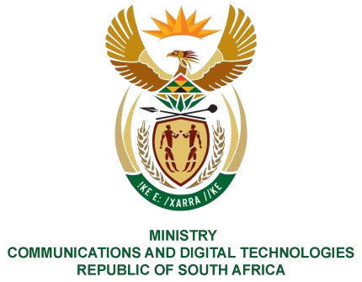
PARLIAMENT OF THE REPUBLIC OF SOUTH AFRICA
NATIONAL ASSEMBLY
WRITTEN REPLY

QUESTION NO: 42
DATE OF PUBLICATION: 10 February 2023
QUESTION PAPER NO: 01
Ms D Kohler (DA) to ask the Minister of Communications and Digital Technologies:
- What is the current status of the application from a certain company (name furnished) to obtain licencing approval to introduce reliable, high-speed satellite internet access to all rural communities in the Republic.

- Whether the Government is demanding that the specified company gives away an ownership share to a local black economic empowerment (BEE) partner before approving its licencing application, if not, why not; if so, (a) what are the relevant details and (b) who is the
Government’s preferred BEE partner for the transaction.

- What are the reasons that the launch of the company in the Republic has been indefinitely delayed while other African countries, including Mozambique, Nigeria, Angola, Eswatini, Gabon, Kenya, Malawi, Rwanda, and Tanzania, will all gain access to the services of the company in early 2023?
NW42E REPLY:

I have been advised by ICASA as follows:

- The Authority has no information in its possession indicating that StarLink has submitted an application either for Radio Frequency Spectrum, Individual Electronic Communications
PQ 42: Hon.D Kohler (DA) to ask the Minister of Communications and Digital Technologies

Network Service (I-ECNS) and an Individual Electronic Communications Service (I-ECS) licences or transfer applications to the Authority.

- The Authority’s prevailing legislative and regulatory provisions section 9(2) (b) of the Electronic Communications Act 36 of 2005 read with regulation 3(4) of the Regulations in respect of the Limitations of Control and Equity Ownership by Historically Disadvantaged Groups (HDGs) 2021, requires Individual IECS/IECNS applicants or licensees to have a minimum 30% equity ownership held by persons from historically disadvantaged groups (HDGs), which includes black people, women, youth and people with disabilities. Therefore, in order for Starlink to operate in South Africa, they require the IECS and IECNS licences and to comply with the above.

- See (a) above.

Thank You.

PQ 42: Hon. D Kohler (DA) to ask the Minister of Communications and Digital Technologies, NW42E

