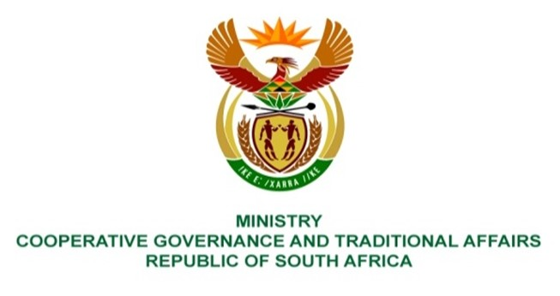

NATIONAL ASSEMBLY
WRITTEN

QUESTION NUMBER 4184
DATE OF PUBLICATION: 11 NOVEMBER 2022

QUESTION:

4184. Ms E R J Spies (DA) to ask the Minister of Cooperative Governance and Traditional Affairs:

Whether the Community Work Programme has recorded any cases of sexual harassment against participants over the past five years; if not, what is the position in this regard; if so, what (a) are the relevant details and (b) action was taken against the perpetrators? NW5250E

REPLY:

No, there are no recorded cases of sexual harassment against participants over the past five years in the Community Works Programme which have been brought to my attention.

BACKGROUND INFORMATION:

