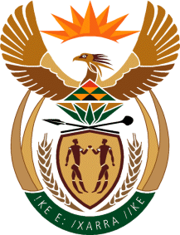

MINISTER IN THE PRESIDENCY: REPUBLIC OF SOUTH AFRICA
Private Bag X1000, Pretoria, 0001, Union Buildings, Government Avenue, PRETORIA
Tel: (012) 300 5200, Website: www.thepresidency.gov.za

NATIONAL ASSEMBLY
WRITTEN QUESTION FOR WRITTEN REPLY

QUESTION NUMBER: 4182
DATE OF PUBLICATIONS: 14 November 2022

Mr H C C Krüger (DA) to ask the Minister in The Presidency: [Interdepartmentally transferred from Small Business Development with effect Monday, 14 November 2022]:

Given that the President of the Republic, Mr M C Ramaphosa, has established the Red Tape Unit at the beginning of the year, (a) what is the definition that the specified unit uses to identify red tape and (b) does the unit enforce the use of the definition to all ministerial departments? NW5248E"

REPLY
- The red tape definition that the Red Tape Reduction Team in The Presidency is using at present is the following: “Red Tape can be defined as rules, regulations, and/or bureaucratic procedures and processes that are excessively complex and which impose unnecessary delay(s), inaction and/or costs that exceed their benefits, and/or is no longer effective in achieving the purpose for which they were originally created”. (Original source: Guidelines for Reducing Municipal Red Tape, 2013). The focus is specifically on red tape within government that inhibits economic growth and job creation in key areas of the economy, working with relevant role-players across government, and outside of government.
- The Red Tape Reduction Team does not have enforcement powers but it does draw on the strategic leadership, convening and coordinating authority of The Presidency in working with departments and agencies firstly in identifying priority red tape issues and secondly in addressing them.

Thank You.

