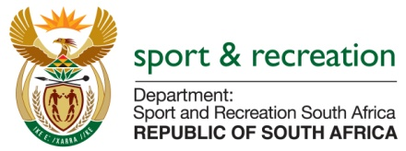

PARLIMENTARY QUESTION FOR THE MINISTER

QUESTION NO 4181

4181. Mr D Bergman (DA) to ask the Minister of Sport and Recreation:

(1) Whether he has given any incentive cheques to any athletes since the start of his tenure as Minister of his department in November 2010; if not, what is the position in this regard; if so, in each case (a) which athletes received the specified cheques, (b) on what date and (c) what was the amount; Monday, 30 November 2015 1604 INTERNAL QUESTION PAPER: NATIONAL ASSEMBLY NO 51 - 2015
(2) whether any of the specified cheques have been paid to para-athletes since the start of his tenure as Minister of his department in November 2010; if not, what is the position in this regard; if so, in each case (a) which para-athletes received the specified cheques, (b) for which (i) games and/or (ii) meetings and (c) what was the amount? NW5057E

Reply

The Department is currently sourcing the information required.

