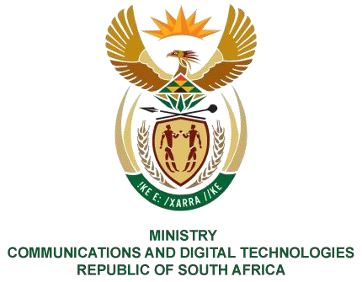
PARLIAMENT OF THE REPUBLIC OF SOUTH AFRICA
NATIONAL ASSEMBLY WRITTEN
REPLY
QUESTION: 418

DATE OF PUBLICATION: 24 February 2023

QUESTION PAPER No: 4

Ms D Kohler (DA) to ask the Minister of Communication and Digital Technologies:

(a) What amount (i) will the new SA Broadcasting Corporation (SABC) 24 hour news channel cost, (ii) does the SABC expect to generate an income or profit from the specified channel and (iii) where is the SABC getting the money to fund the new channel?

REPLY

I have been advised by SABC as follows:
i) The News Channel has been running since 2019 and no additional budget will be required as the activities will be accommodated within current resources. ii) Yes, the channel is expected to attract income through advertising and partnerships.

iii) No funding is required.

Thank You.

PQ 418 Ms D Kohler (DA) to ask the Minister of Communications and Digital Technologies

