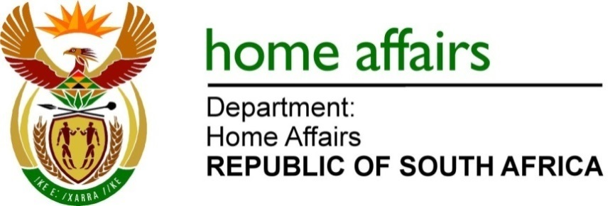

NATIONAL ASSEMBLY

QUESTION FOR WRITTEN REPLY

QUESTION NO. 418

DATE OF PUBLICATION: FRIDAY, 25 FEBRUARY 2022

INTERNAL QUESTION PAPER 4 – 2022

418. Mr A M Shaik Emam (NFP) to ask the Minister of Home Affairs: [75] [Question submitted for oral reply now placed for written reply because it is in excess of quota (Rule 137(8))]:

What measures does he intend to put in place to prevent hijacked and/or stolen vehicles from the Republic crossing our borders? NO483E

REPLY:

Currently, it is still members of the South African National Defence Force (SANDF) who patrol our national borderline. Working with members of the South African Police Services (SAPS), the SANDF has put measures in place, to prevent either hijacked and/or stolen cars from crossing our borders. In this regard, the modus operandi and the escape routes of the car hijacking syndicates have been identified. They mostly include our eastern border between Kwazulu-Natal and Mozambique and the norther border between Limpopo and Zimbabwe. As a result, the military officers are statically deployed for 24 hours in those identified areas in order to intercept and thwart the activities of the syndicates.

As for the immediate future, it should be noted that the Border Management Authority issued a public advertisement to recruit 200 patriotic Border Guards who will be deployed in these vulnerable segments of the borderline to augment the work of the SANDF officers. In this regard, the Border Guards will be statically deployed for 24 hours in the identified vulnerable segments and this would allow members of the SANDF to freely apply their high mobility deployment strategy for countering any illegal syndicated activities, including the undue expatriation of our stolen vehicles. In addition, the BMA has started engagements with our immediate neighbours through the Joint Technical Committees to devise strategies to jointly address these inter-jurisdictional crimes.

END

