

**MINISTRY: PUBLIC SERVICE AND ADMINISTRATION**

**REPUBLIC OF SOUTH AFRICA**

**NATIONAL ASSEMBLY**

**QUESTION FOR WRITTEN REPLY**

**QUESTION NO**.: **4173.**

**Ms A T Lovemore (DA) to ask the Minister of Public Service and Administration:**

(1) (a) For which (i) departments and/or (ii) municipalities were citizen report cards compiled in the (aa) 2013-14, (bb) 2014-15 and (cc) 2015-16 financial years and (b) on what basis were the specified selections made;

(2) (a) what were the scores for each of the entities assessed in the specified financial years, expressed as the (i) overall score and (ii) score per assessed aspect for each assessed entity, (b)(i) what score is considered acceptable for each aspect and (ii) why and (c) what are the details of the action taken in the event of a score that indicates unacceptable customer service? NW5049E

**REPLY**

1. (a) (i) (aa)(bb) The Citizen Report Cards (CRC) were compiled for the following:

* Department of Basic Education;
* Department of Health:
* Department of Home Affairs;
* South African Police Service; and
* South African Social Security Agency.

(ii) (aa)(bb) The Citizen Report Cards were compiled for the following:

* Ga-Segonyana Local Municipality;
* Mookgopong Local Municipality;
* Okhahlamba Local Municipality;
* Matatiele Local Municipality;
* Emalahleni Local Municipality;
* Moretele Local Municipality;
* City of Mangaung (Botshabelo);
* City of Johannesburg (Diepsloot and Alexandra); and
* City of Cape Town (Gugulethu and Khayelitsha).

(cc) None. The Citizen Report Card survey was conducted in the 2013-14 financial year and the subsequent reports were finalised in the 2014-15 financial year.

(b) The selection was based on the Medium Term Strategic Framework (MTSF) priorities, which set out key focus areas of the departments over the MTSF period. One municipality per province was chosen to benefit from the survey and the selection of the municipality in every province was based on the readiness of the municipality to accommodate the study within the set timelines.

(2) (a) (i) The overall scores for each department and municipality are shown herewith below on figure 1 and figure 2 respectively:

Figure 1: Overall Ranking of Departments

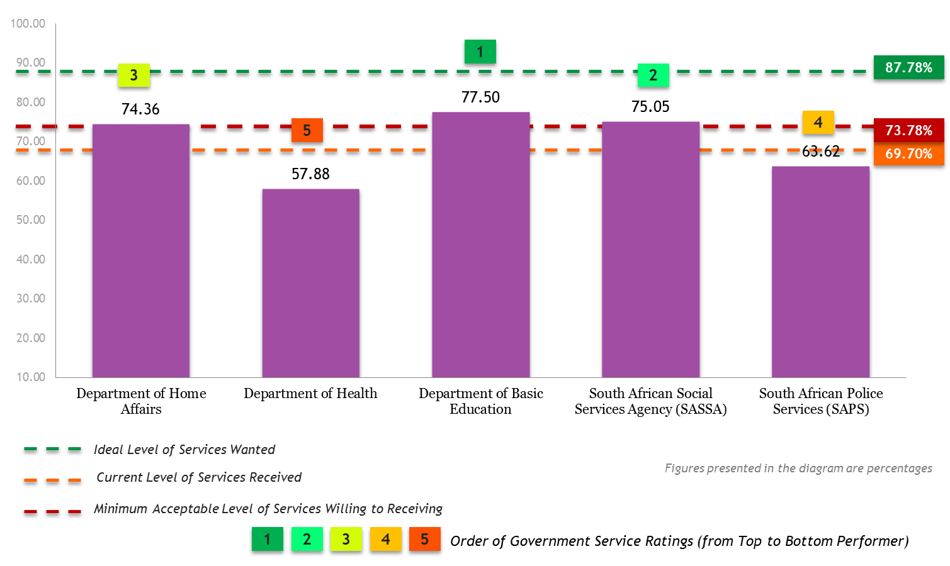

Figure 2: Overall Ranking of Municipalities

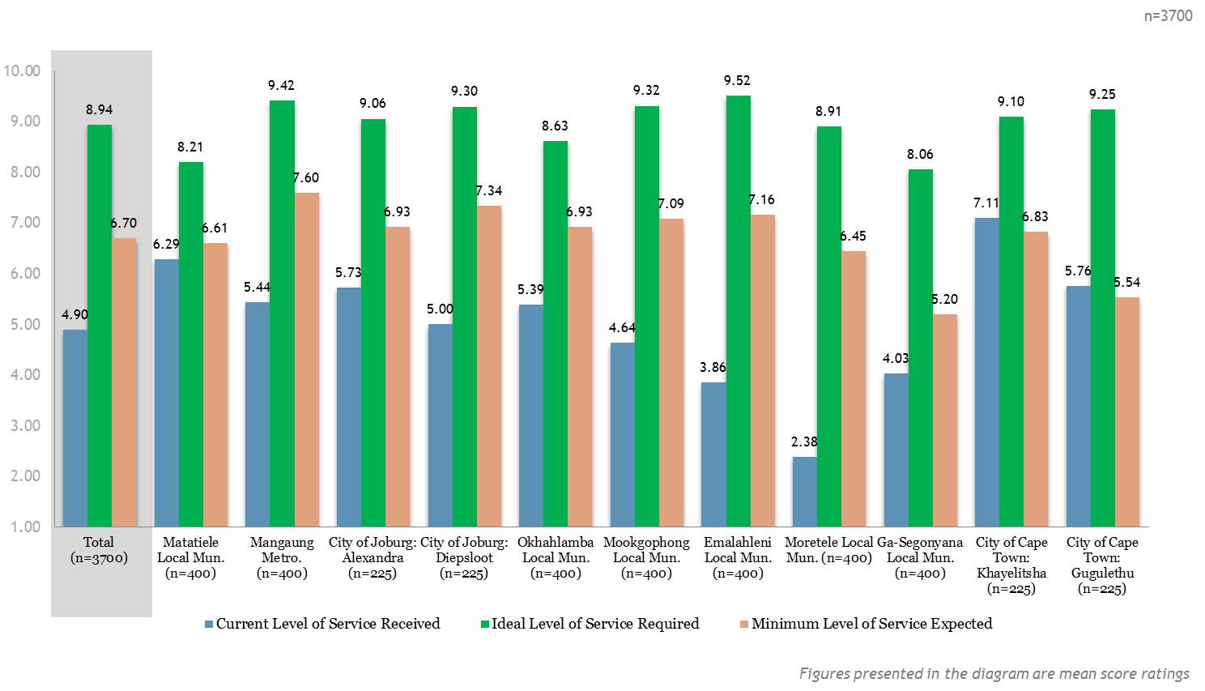

(2) (a) (ii) The scores are reflected on figure 3 and figure 4 herewith below. The departments were assessed on Accessibility, Reliability, Quality of Service, Staff Performance, Transparency and Openness and also Avenue for Redress whilst the municipalities were assessed using the Batho Pele principles. The satisfaction of citizens against a range of municipal basic services was also assessed.

Figure 3: Ranking of Departments against service delivery attributes



Figure 4: Performance of municipalities *against Batho Pele principles*

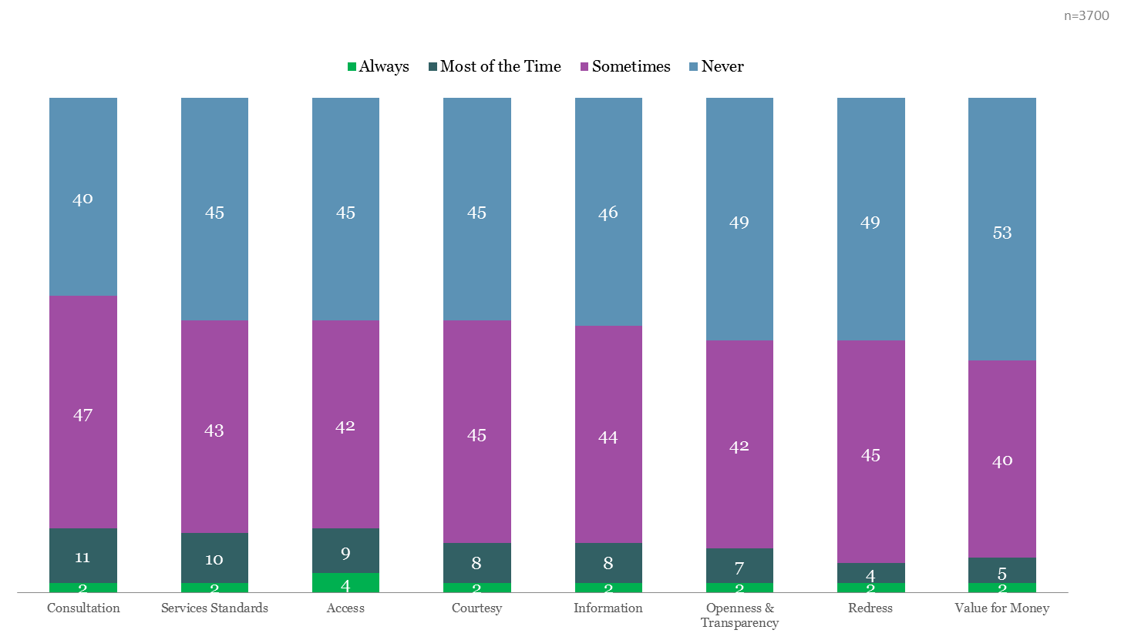

(2) (b) (i) The benchmarks reflected in figure 1 and figure 2 above were on the following:

* Minimum level of service expected and
* Ideal level of service required.

|  |  |  |
| --- | --- | --- |
|  | **Minimum service expected** | **Ideal level of service required** |
| Departments | 73.78% | 87.78% |
| Municipalities | 67.00% | 89.40% |

(ii) The benchmarks indicated above are considered acceptable as they were sourced from the citizens regarding the level of service they expected and required from the assessed government departments and municipalities..

(c) Action taken was the development of Service Delivery Improvement Plans, which entail interventions to improve performance.