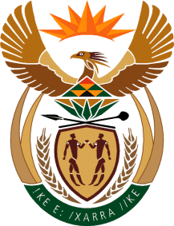

MINISTRY OF TOURISM

REPUBLIC OF SOUTH AFRICA

Private Bag X424, Pretoria, 0001, South Africa. Tel. (+27 12) 444 6780, Fax (+27 12) 444 7027

Private Bag X9154, Cape Town, 8000, South Africa. Tel. (+27 21) 469 5800, Fax: (+27 21) 465 3216

Ref: TM 2/1/1/10

NATIONAL ASSEMBLY:

QUESTION FOR WRITTEN REPLY:
Question Number: 4169
Date of Publication: 30 November 2015
NA IQP Number: 51
Date of Reply: 11 December 2015

Ms D Carter (Cope) to ask the Minister of Tourism:
Whether he has succeeded in persuading the Minister of Finance to establish a Tourism Development Fund that will cater for all aspects of the tourism sector in order to increase infrastructure, improve experiences and facilities for tourists, introduce innovative ideas and help small operators expand their businesses; if not, why not; if so, what are the relevant details?
NW5045E

REPLY:
There has been no attempt to persuade the Minister of Finance to establish a Tourism Development Fund. The tourism development aspects raised in the question are funded through existing funding mechanisms in the department provided for by the National Treasury within the current appropriated budget. These include inter alia the Tourism Incentive Programme (TIP), the Social Responsibility Implementation (SRI) Programme and the Strategic Partners in Tourism initiative.

