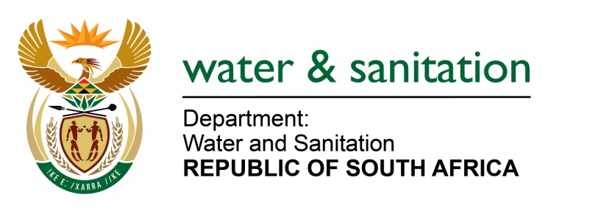

NATIONAL ASSEMBLY

FOR WRITTEN REPLY

QUESTION NO 4159

DATE OF PUBLICATION IN INTERNAL QUESTION PAPER: 20 NOVEMBER 2015
(INTERNAL QUESTION PAPER NO. 50)

4159. Ms D van der Walt (DA) to ask the Minister of Water and Sanitation:
(1) Whether there are any investigations into the appointment of the contractor in the Vingerkraal borehole project to supply additional water to Bela-Bela; if not, why not; if so, (a) who is the appointed contractor, (b) what is the scope of the contractor’s work, (c) what is the value of the contract, (d) what process was followed to appoint the contractor, (e) what is the status of the contract and (f) how much water will be provided to Bela-Bela;
(2) whether a telemetry system will be installed in Bela-Bela; if not, why not; if so, (a) when and (b) what are the further relevant details in this regard? NW5032E
---00O00---
REPLY:
- The Vingerkraal Borehole will not be providing water to Bela-Bela but Vingerkraal community only. My Department and the municipality are not aware of any investigations regarding the service providers in Vingerkraal.

(1)(a) The service provider appointed for Vingerkraal is AURECON SOUTH AFRICA (Pty) Ltd employing a Turn - key implementation method to fast track the project.

(1)(b) The summary of scope is: Ground water study and borehole siting drill and equip 2 boreholes, erect 40kl storage tanks in a tank stand, reticulation pipelines and stand taps, and link the new pipelines to existing network.

(1)(c) The total project cost is R1 700 000.00 (excl: VAT) including professional fees and construction works as per (b) above.

(1)(d) The appointed service provider is in the panel of Civil Engineers appointed following the Supply Chain Regulations and policy of the municipality.

(1)(e) Currently the Geohydrology studies are complete with 3 boreholes drilled; borehole testing and quality analysis is in progress.

(1)(f) The drilled borehole will yield ±4 litres/second and will be able to provide 200 kilolitres/day to Vingerkraal community.

(2) (a) The Bela-Bela Local Municipality is busy with a demand management programme which include bulk meter installations for remote monitoring;
(b) The project is funded by Municipal Water Infrastructure Grant (MWIG) and is currently in its design phase for a remote monitoring technology.
--00O00---

