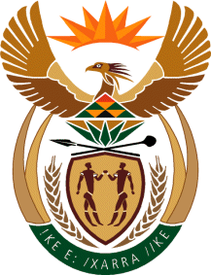

MINISTRY: COMMUNICATIONS
REPUBLIC OF SOUTH AFRICA
Private Bag X 745, Pretoria, 0001, Tel: +27 12 473 0164 Fax: +27 12 473 0585
Tshedimosetso House,1035 Francis Baard Street, Tshedimosetso House, Pretoria, 1000

NATIONAL ASSEMBLY
QUESTION FOR WRITTEN REPLY
QUESTION NUMBER: 4153 OF 2015

Ms P T van Damme (DA) to ask the Minister of Communications:
(1) Whether she will provide the exact details of the formalised communications relations agreement with Vietnam entered into by her in October 2015; if not, why not; if so, what are the relevant details; (2) whether the specified formalised agreement includes a programme for the training of journalists; if not, what is the position in this regard; if so, what are the relevant details?
___________________________________________________________________
REPLY: MINISTER OF COMMUNICATIONS

(1) & (2) The Department is unable to provide exact details of a formalised communications relations agreement with Vietnam because it has not entered into any agreement with Vietnam.

MR NN MUNZHELELE
DIRECTOR GENERAL [ACTING]
DEPARTMENT OF COMMUNICATIONS
DATE:

MS AF MUTHAMBI (MP)
MINISTER OF COMMUNICATIONS
DATE

