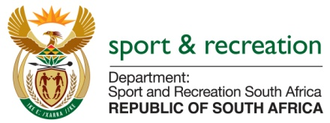

PARLIMENTARY QUESTION FOR THE MINISTER

QUESTION NO 4149

QUESTION
4149. Mr M S Malatsi (DA) to ask the Minister of Sport and Recreation:
Whether, since his reply to question 3830 on 3 November 2015 and since his reply to oral question 303 on 19 August 2015, (a) he, (b) his department and/or (c) the National Prosecuting Authority have been (i) contacted and/or (ii) been in contact with the Legal Attaché of the United States of America’s (USA’s) Federal Bureau of Investigations since 1 July 2015 in respect of the USA’s Attorney General’s investigation and indictment of corruption with regard to the 2010 Soccer World Cup tournament; if not, why have they not contacted USA law enforcement authorities to initiate preliminary investigation to establish the identity of the two South Africans mentioned in the indictment; if so, in each case (aa) how many times was contact made, (bb) how was the contact conducted and (cc) what are dates of the discussions? NW5022E
Reply
In terms of Government protocol, Sport and Recreation South Africa as the department cannot contact the Legal Attaché of the United States of America's (USA's) Federal Bureau of Investigations, directly. It has been done via DIRCO. Ministry has already written to the Minister at DIRCO requesting her to solicit all the information and evidence that the USA Government purports to have in their possession. Further to this we have also interacted with Minister of Justice upon his receipt of the indictment from the USA government with the Legal Attaché of the United States of America's (USA's) Federal Bureau of Investigations, and agreed with the Minister of Justice that the matter be referred to the IMC on Corruption, DIRCO and Chairperson of Anti-Corruption.

