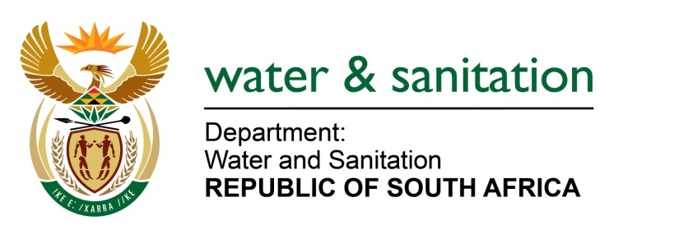

NATIONAL ASSEMBLY

FOR WRITTEN REPLY

QUESTION NO 4143

DATE OF PUBLICATION IN INTERNAL QUESTION PAPER: 20 NOVEMBER 2015
(INTERNAL QUESTION PAPER NO. 50)

4143. Mrs Z B N Balindlela (DA) to ask the Minister of Water and Sanitation:
(1) (a) What is the estimated amount of kilometers of water pipes that were replaced in each of the metropolitan municipalities in the (i) 2011-12, (ii) 2012-13, (iii) 2013-14 and (iv) 2014-15 financial years and (b) what was the estimated cost of the replacement in each specified financial year;
(2) how many litres of water pipeline is located in each metropolitan municipality;
(3) whether each metropolitan municipality has an official pipeline replacement programme; if not, why not; if so, what are the annual targets? NW5016E
---00O00---
REPLY:

Requesting the Honorable Member to refer the question to the Minister of Cooperative Governance and Traditional Affairs (Cogta) who is in a better position to respond to the estimated amount of kilometers of water pipes that were replaced in each of the metropolitan municipalities.
---00O00---

