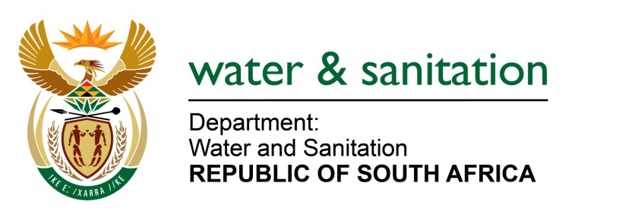

NATIONAL ASSEMBLY

FOR WRITTEN REPLY

QUESTION NO 4141

DATE OF PUBLICATION IN INTERNAL QUESTION PAPER: 20 NOVEMBER 2015
(INTERNAL QUESTION PAPER NO. 50)

4141. Mrs Z B N Balindlela (DA) to ask the Minister of Water and Sanitation:
What are the details of the infrastructure maintenance plans for the next 10 to 15 years to ensure a reduction in non-revenue water for (a) Makana in the Eastern Cape, (b) Ndwedwe in KwaZulu-Natal, (c) Letsemeng in the Free State, (d) Knysna in the Western Cape, (e) Nama Khoi in the Northern Cape, (f) Moses Kotane in the North West, (g) Emfuleni in Gauteng, (h) Polokwane in Limpopo and (i) Emalahleni in Mpumalanga local municipalities? NW5014E
---00O00---
REPLY:

Requesting the Honorable Member to refer the question to the Minister of Cooperative Governance and Traditional Affairs (Cogta) who is in a better position to respond to the infrastructure maintenance plans for the next 10 to 15 years to ensure a reduction in non-revenue water for the nine provinces.
---00O00---

