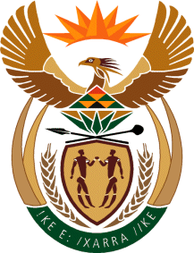

MINISTRY: COMMUNICATIONS
REPUBLIC OF SOUTH AFRICA
Private Bag X 745, Pretoria, 0001, Tel: +27 12 473 0164 Fax: +27 12 473 0585
Tshedimosetso House,1035 Francis Baard Street, Tshedimosetso House, Pretoria, 1000

NATIONAL ASSEMBLY
QUESTION FOR WRITTEN REPLY
QUESTION NUMBER: 4129 OF 2015
DATE OF PUBLICATION: 30 OCTOBER 2015
Ms V van Dyk (DA) to ask the Minister of Communications:
(1) (a) How many TV licenses were (i) issued and (ii) renewed by 30 September 2015 and (b) how many were not renewed; (2) (a) what amount is owed to the SA Broadcasting Corporation for unpaid licenses and (b) what is the cost of actions taken to recoup the specified debts? NW5002E

REPLY: MINISTER OF COMMUNICATIONS

(1)(a) (i) 4 434 000
(ii) 1 741 000
(b) 2 692 000

(2)(a) R32 502bn
(b) April to 30 September 2015, collection costs were R75.4m, projected for Apr – Mar 2016 is R168m.

MR NN MUNZHELELE
DIRECTOR GENERAL [ACTING]
DEPARTMENT OF COMMUNICATIONS
DATE:

MS AF MUTHAMBI (MP)
MINISTER OF COMMUNICATIONS
DATE:

