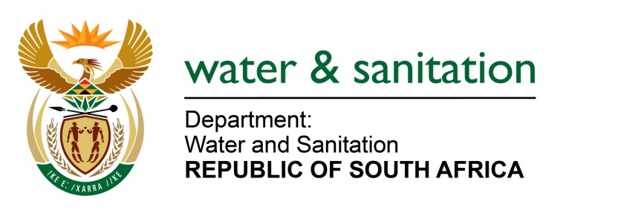

NATIONAL ASSEMBLY

FOR WRITTEN REPLY

QUESTION NO 4123

DATE OF PUBLICATION IN INTERNAL QUESTION PAPER: 20 NOVEMBER 2015
(INTERNAL QUESTION PAPER NO. 50)

4123. Mr T J Brauteseth (DA) to ask the Minister of Water and Sanitation:
(1) With regard to problems associated with sludge at the wastewater treatment plant in Parys, Free State, how will this problem be resolved to prevent pollution in the specified area;
(2) what are the full details of the quality of the water that was tested from the specified plant in the period 1 January 2014 to 31 October 2015;
(3) what is the (a) megaliter of water inflow per day and (b) megaliter of water outflow per day at the specified plant? NW4996E
---00O00---
REPLY:
(1) Ngwathe is currently engaged in a process of research and development on how to utilise alternative ways of sludge disposal. The Municipality is currently looking at piloting the use of sewer sludge for producing energy. This energy will drive the plant during purification process, whilst preventing pollution. The sludge is also available for Local and neighbouring farmers.

(2) Refer to the table below for the waste water quality status of Parys Waste Water Treatment Works (WWTW) (January – October 2015).
Local Municipality |  |  | WWTW | Period 2015 |  |  | Chemical | Physical
Ngwathe LM |  |  | Parys | January  February  March |  |  | 99.9%  0%  99.9% | 75%  77.78%  92.86%
 |  |  |  | April  May  June |  |  | 99.9%  0%  99.9% | 0%  0%  88.89%
 |  |  |  | July  August  September |  |  | 100%  100%  0% | 100%  100%  0%
 |  |  |  | October |  |  | 0% | 0%
 | Colour Codes
 |  | 95-100% |  |  | Excellent
 |  | 90 - ≤ 95 |  |  | Good
 |  | 80- ≤90% |  |  | Satisfactory
 |  | ≤ 80% |  |  | Poor
(3)(a) 7.4 Mega litres of water inflow per day.

(3)(b) 7.4 Mega litres of water outflow per day.
---00O00---

