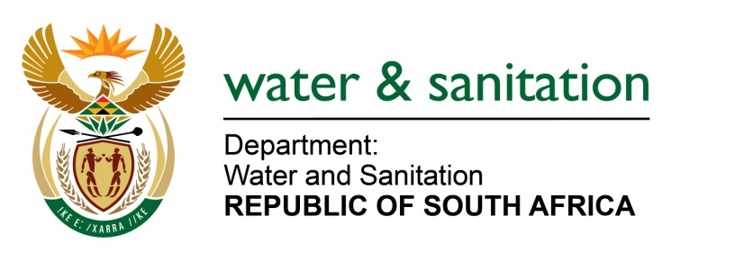

NATIONAL ASSEMBLY

FOR WRITTEN REPLY

QUESTION NO 4122

DATE OF PUBLICATION IN INTERNAL QUESTION PAPER: 20 NOVEMBER 2015
(INTERNAL QUESTION PAPER NO. 50)

4122. Mr P G Atkinson (DA) to ask the Minister of Water and Sanitation:
(1) What is the capacity of the old water purification plant in Parys, Free State?
(2) (a) what will the new purification plant add in mega liters per day, (b) what is the cost of the specified plant, (c) when will the new plant be completed and (d) what was budgeted for this project;
(3) whether the new plant will be completed within the budgeted amount; if not, why not; if so what are the relevant details;
(4) when will a telemetry system be installed at the new plant? NW4995E
---00O00---
REPLY:

- The capacity of the old water purification plant in Parys, Free State, is 15 Mega litres per day

(2)(a) The new purification plant will add 10 Mega litres per day.

(2)(b) The cost of the specified plant will be R34 million.

(2)(c) The new plant will be completed by the end of December 2015.

(2)(d) An amount of R34 million was budgeted for this project.

(3) Yes, it will be completed within the budgeted amount. The cost obviously differs with capacity size. The fluctuations are as a result of the dollar exchange rate, shipping conditions, and the conditions of the site where the plant is built. Such include the turbidity status of the area where the plant is drawing the water, and the overall layout and terrain of the construction area.

(4) The telemetry system is usually installed at the storage reservoirs (and not at the plant) to monitor and manage the water levels. Programmes such as Sequence Control and Data Acquisition (SCADA), is normally utilized for such functions.

The focus of the Water Services Authority (WSA) is to ensure that reservoir levels are
sufficiently filled to provide adequate pressure on the reticulation network and realized sustainable water supply.

---00O00---

