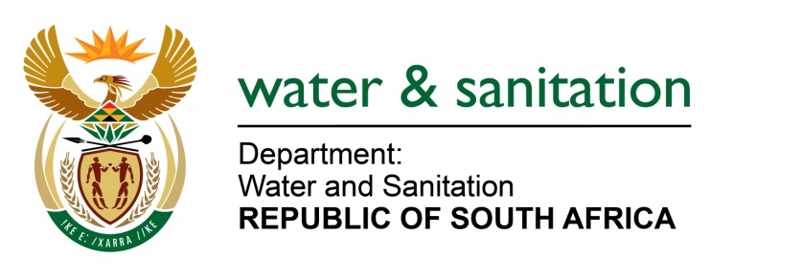

NATIONAL ASSEMBLY

FOR WRITTEN REPLY

QUESTION NO 4121

DATE OF PUBLICATION IN INTERNAL QUESTION PAPER: 20 NOVEMBER 2015
(INTERNAL QUESTION PAPER NO. 50)

4121. Mr P G Atkinson (DA) to ask the Minister of Water and Sanitation:
(1) (a) How many boreholes are used in Vaalwater in Limpopo, (b) how many boreholes are (i) equipped and (ii) functional and (c) what is the water quality of the specified boreholes;
(2) what steps has her department taken to provide a constant supply of water to the community of Vaalwater;
(3) why are water tankers only delivering water in some of the areas and not to all the affected areas in Vaalwater;
(4) with regard to the leaking water reservoirs in Vaalwater, (a) what is the cause of the specified leak and (b) when will this situation be remedied;
(5) what is the (a) medium and (b) long-term plan to resolve the water problems in Vaalwater? NW4994E
---00O00---
REPLY:
(1)(a)There are 7 boreholes used in Vaalwater in Limpopo.

(1)(b)(i) There are 7 equipped boreholes.

(1)(b)(ii) All 7 boreholes are functional.

(1)(c) The quality of water is within the required standard which is SANS 241 of 2015.
(2) The Modimolle Local Municipality (LM) is a Water Service Authority and Water Service Provider, however my Department has allocated an amount of R10 million under the Municipal Water Infrastructure Grant (MWIG) in the current financial year 2015/16 for Modimolle LM. Out of R10 million, Vaalwater is allocated R3.8 million which will be used to supplement the water supply.
(3) The Modimolle LM supplies water through water tankers at Vaalwater merely where there is no reticulation system and any affected areas within Vaalwater.
(4)(a) The cause of the leaks is dilapidated infrastructure.

(4)(b) The Modimolle LM is finalizing the procurement processes of appointing contractors to seal the leaking reservoirs/towers.

-2-

(5)(a) Medium term solution is that the municipality is currently sourcing to explore groundwater development to supplement the current water supply to Vaalwater.

(5)(b)My Department is currently conducting the Mokolo Crocodile Feasibility Study where Vaalwater is anticipated to be covered by the outcomes.

---00O00---

