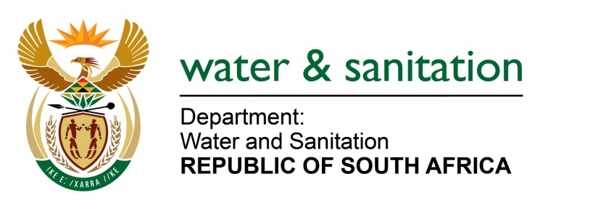

NATIONAL ASSEMBLY

FOR WRITTEN REPLY

QUESTION NO 4120

DATE OF PUBLICATION IN INTERNAL QUESTION PAPER: 20 NOVEMBER 2015
(INTERNAL QUESTION PAPER NO. 50)

4120. Mr P G Atkinson (DA) to ask the Minister of Water and Sanitation:
(1) Whether, with regard to the non-functionality of the current wastewater treatment plant with only one aerator working in Modimolle in Limpopo, she took any steps to intervene in this situation; if not, (a) why not and (b) what steps will her department take in this regard;
(2) whether she took any steps to intervene in the pollution of Modimolle’s water with blood and fat by the abattoir; if not, (a) why not and (b) what steps will her department take in this regard;
(3) (a) when will Modimolle’s new wastewater treatment plant be completed, (b) what capacity will the new plant have, (c) what will the final cost be and (d) what was the budgeted amount in this regard? NW4993E
---00O00---
REPLY:

(1) The Modimolle Wastewater treatment plant is functional.

(1)(a) The municipality has appointed contractor to upgrade the wastewater treatment works from the initial capacity of 3.5 megalitres per day to 6.5 megalitres per day and to also repair aerators.

(2) To date two Directives dated 22 April 2014 and 21 August 2014 have been issued to the Municipality for the abattoir manhole blockages and ongoing site inspections are conducted to ensure compliance to the Directive and monitor the situation of which the latest inspection was conducted on the 06 November 2015 and it was found that the manhole was operating well and there were no blockages.

(3)(a) The anticipated completion date for Modimolle Waste Water Treatment is February 2016.
(3)(b) The capacity of the new plant will be 6.5 megalitres per day. (c) The final cost will be R43 million.
(3)(d) The budget amount for the project is R43 million.
---00O00---

