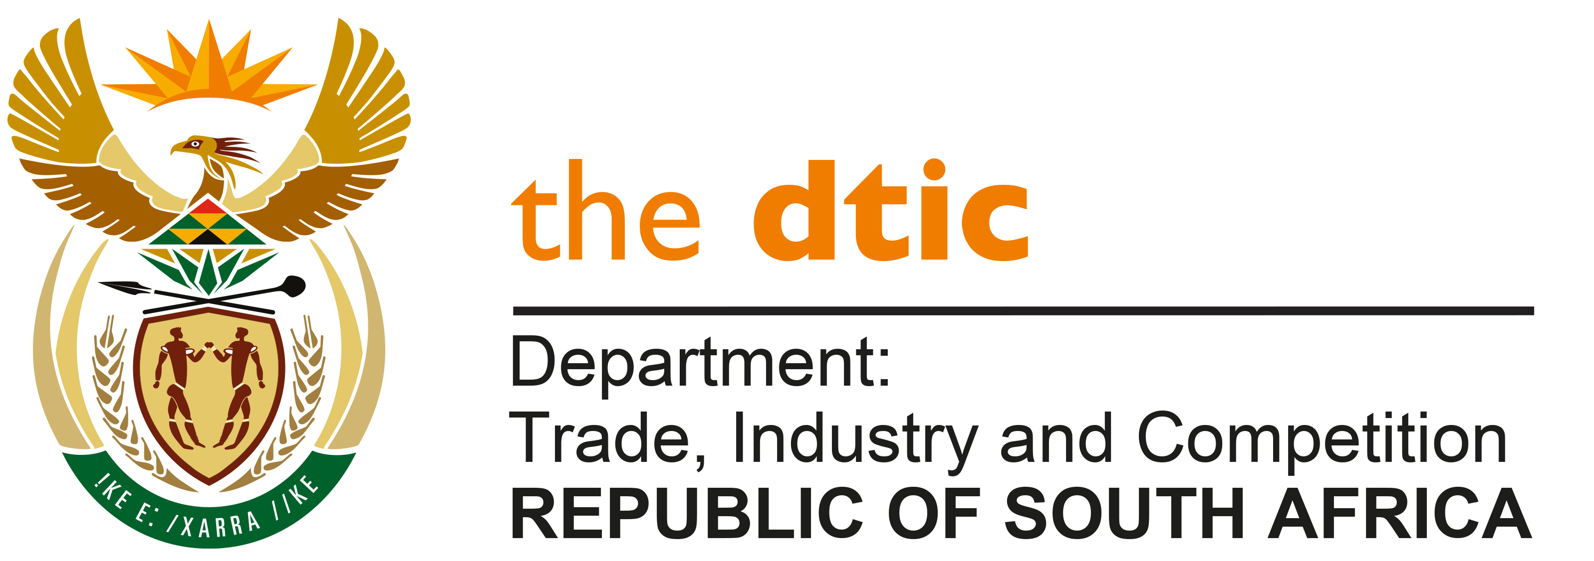

THE NATIONAL ASSEMBLY

QUESTION FOR WRITTEN REPLY

QUESTION NO. 4114

DATE PUBLISHED: 4 NOVEMBER 2022

Mr V Pambo (EFF) to ask the Minister of Trade, Industry and Competition:

What are the full details of economic data and/or evidence that he can provide to prove that foreign direct investment in the Republic has had a direct proportional relationship with (a) economic growth and (b) job creation (i) in the 2021 22 financial year and (ii) since 1 April 2022? NW5127E

REPLY:

Domestic economic growth is the aggregation of multiple, complex streams of for example: production, consumption, expenditure, imports and exports. These are in turn affected by a wide range of domestic and global factors. It is not advisable to reduce these complex interactions to a simple direct and/or proportional relationship. Subject to this caution, the following information has been provided to me by the dtic.

In the Financial year 2021-22, Foreign direct investment (FDI), measured as investment liability inflows by the South African Reserve Bank (SARB), increased from R17.3 billion at the beginning of the 2021/22 financial year to R39.9bn at the end of the financial year, growing by 130.8% during the 2021/22 financial year. In the same period, GDP grew by 1.3%, from R4.5 trillion (tr) to R4.6trn during the same period. Some studies indicate that in South Africa, FDI and economic growth are positively related (Masipa, 2014; Awolusi and Adeyeye, 2016; Makhoba and Zungu, 2021).

In Quarter 1 2022/23 (April to June 2022), FDI declined (-34.2%) quarter-on-quarter while economic growth contracted (-0.7%) quarter-on-quarter.

Regarding Job creation, in the Financial year 2021/22: Foreign direct investment (FDI), measured as investment liability inflows, by the South African Reserve Bank (SARB), increased from R17.3 billion at the beginning of the 2021/22 financial year to R39.9bn at the end of the financial year, growing by 130.8% during the 2021/22 financial year. During the same period, Statistics South Africa (StatsSA) reported that employment contracted by 0.2%, with employment declining from 14.94 million to 14.91 million. Some empirical studies have found a positive relationship between FDI and job creation in South Africa (see Masipa, 2014).

Quarter 1 of this Financial Year 2022/23, Employment increased by 4% quarter-on-quarter while FDI declined (-34.2%) quarter-on-quarter.

Lags in an increase (or decrease) in investment and a subsequent increase (or decrease) in employment may also not follow in the same year, but may lag the change.

-END-

Masipa, T. 2014. The Impact of Foreign Direct Investment on Economic Growth and Employment in South Africa: A Time Series Analysis. Mediterranean Journal of Social Sciences, 5(25), 18-27.
Awolusi, OD. and Adeyeye, OP. (2016). Impact of foreign direct investment on economic growth in Africa. Problems and Perspectives in Management, 14(2-2), 289-297. doi:10.21511/ppm.14(2-2).2016.04.
Makhoba, BP. and Zungu, LT. 2021. Foreign Direct Investment and Economic Growth in South Africa: Is there a Mutually Beneficial Relationship? African Journal of Business and Economic Research, 16(4).

